PROJECT DOCUMENTATION

QuasarEdu
Scholarship Management System

Powered By Project QuasarX
Database: ft | Platform: Windows Desktop + Web API

2026

PROPOSAL

1.1 Title
QuasarEdu — Scholarship Management System
Developed under Project QuasarX

1.2 Introduction
QuasarEdu is a comprehensive Scholarship Management System designed to streamline and digitize the end-to-end lifecycle of student scholarship applications. The system provides a Windows desktop client for students and administrators, and a companion ASP.NET Core web API that handles identity and fingerprint verification through any modern mobile browser.
The platform addresses a common pain point in educational institutions: the manual, error-prone process of collecting student information, evaluating eligibility, managing documents, and confirming applicant identity. QuasarEdu automates all of these steps, introduces biometric/identity checks to prevent fraud, and offers a clean, role-based interface for both students and administrators.

1.3 Main Features

Student-Facing Features
- Secure registration and email OTP verification
- Comprehensive profile builder (personal, academic, financial, and biometric data)
- Smart scholarship discovery — only eligible scholarships are presented
- One-click scholarship application with optional personal statement
- Smart eligibility engine that ranks and color-codes scholarships based on student CGPA, family income, degree program, and semester
- Ability to save (bookmark) scholarships for later
- Real-time application status tracking (Pending / Withdrawn / Approved / Rejected)
- Withdraw pending applications and reapply for rejected or withdrawn ones
- In-app notifications for all status changes
- Mobile-based identity verification flow (face selfie + fingerprint/biometric/PIN)
- Document upload with type-based validation (.pdf, .jpg, .jpeg, .png only)
- Printable application receipt

Administrator Features
- Full scholarship CRUD (create, read, update, deactivate)
- Stats dashboard: total scholarships, total applications, pending reviews, approval rate
- Pie chart showing application status distribution
- Automated status notification emails to students
- Filterable student list with popup profile view
- Centralized document viewer and printer
- PDF receipt generation for any approved application
- Student list view with profile pop-up
- Application review dashboard — approve or reject with comments
- System-wide notification broadcasting

System & Security Features
- Role-based access control (Student / Admin)
- Brute-force login protection (5 attempts → 15-minute lockout)
- BCrypt password hashing with plain-text migration fallback
- SQL injection prevention via parameterized queries throughout
- Concurrency-safe approval flow (WHERE Status = 'Pending' guard)
- Email OTP for account verification and password reset
- Tamper-resistant, token-based verification links (1-hour TTL)
- Race-condition-safe atomic token consumption
- Cloudflare Tunnel integration for secure local-to-internet API exposure
- Transaction-wrapped database writes
- Transactional application submission and review updates with rollback
- Toast notification system (Success / Error / Info / Warning)

1.4 Tools and Technologies Used
Layer | Technology | Purpose
Desktop Client | C# Windows Forms (.NET 10) | Main application UI for students and admins
Web API | ASP.NET Core Minimal API (.NET 8) | Fingerprint / identity verification endpoint
Database | Microsoft SQL Server | Relational data store (database name: ft)
ORM / Data Access | Microsoft.Data.SqlClient + Raw SQL | ADO.NET-style repository pattern
Tunnel | Cloudflare Tunnel (cloudflared) | Expose local API to internet over HTTPS
Email (SMTP) | System.Net.Mail (Gmail SMTP) | OTP, verification & confirmation emails
IDE | Visual Studio 2022 | Primary development environment
Version Control | Git | Source control
UI Framework | .NET Windows Forms | net10.0-windows
UI Component Library | Guna.UI2.WinForms | v2.0.4.7
Charts | Guna.Charts.WinForms | v1.1.0
Password Hashing | BCrypt.Net-Next | v4.2.0
Verification API | ASP.NET Core Minimal API | . NET 8
PDF Generation | QuestPDF | v2026.5.0

CHAPTER ONE — Analysis & Design Phase

2.1 Business Requirements & Rules

User Management
- Every student must register with a unique email address.
- An OTP is sent to the registered email; the account is marked verified only after correct OTP entry within 5 minutes (max 3 attempts).
- Passwords must be at least 6 characters. Passwords are hashed using BCrypt before storage.
- Login is locked for 15 minutes after 5 consecutive failed attempts (admin accounts are exempt).
- A student can reset their password via email-OTP flow at any time.
- A student must complete identity verification (face selfie plus fingerprint / biometric / PIN) through the mobile web link before any scholarship application is accepted.

Student Profile
- Each student account is linked to exactly one detailed Student profile record.
- The profile captures personal information (name, CNIC, DOB, gender, religion, disability), address, academic record (SSC, HSSC, CGPA, university, roll number), and financial data (family income).
- Profile completeness is enforced before applying: 13 mandatory fields must be filled and identity verification must be completed.
- CNIC must be exactly 13 digits; mobile must match +923xxxxxxxxx or 03xxxxxxxxx format; CGPA must be between 0.00 and 4.00.

Scholarships
- Only Admin users may create or edit scholarships.
- Each scholarship has a title, description, eligibility text, monetary amount, deadline, required document list, minimum CGPA, maximum family income, target degree program, target semester/year, and a need-based flag.
- Each scholarship can specify eligibility filters: minimum CGPA, maximum family income, degree program, and semester.
- Scholarships have an active flag and a deadline; expired or deactivated scholarships are hidden from students.
- Students see only scholarships for which they are eligible based on their profile data.

Applications
- A student may apply once per scholarship. A second application is permitted only if the previous one was Rejected or Withdrawn.
- Application submission validates CGPA, family income, deadline, and active status in a stored procedure before inserting the record.
- Admins review applications and set the status to Approved, Rejected, optionally attaching a comment.
- Submission requires all required documents to be uploaded for the scholarship (checked at form level).
- Admin can approve or reject with optional comments; an email notification is sent to the student.
- Need-based approvals instruct the student to visit the office with their printed receipt.
- The application record tracks FingerprintVerified and FingerprintVerifiedAt timestamps.

Documents
- Students upload required documents (CNIC front/back, SSC certificate, HSSC certificate, domicile, affidavit, student image) during the application flow.
- Identity verification captures a face selfie plus one of: finger-camera photos (up to 4 captures), biometric sensor credential, or PIN credential.
- Identity Verification documents are embedded in PDF receipts.
- All uploaded files are stored on the server file system under C:\ScholarshipApp\Uploads; the Documents table keeps metadata (type, filename, path).
- Documents belong to a student (by email) and have a type, filename, and physical file path.
- Allowed upload extensions: .pdf, .jpg, .jpeg, .png.
- Documents can be opened or printed directly from the application.

Notifications
- The system auto-creates a notification whenever an application status changes or verification is completed.
- Students can view all notifications in the Notifications form; unread notifications are visually distinguished.
- The student's notification list shows message, date, and read status.

Reporting
- PDF receipts are generated using QuestPDF and include student info, scholarship details, application status, admin comments, and embedded identity verification images.

Identity Verification
- A student must verify their identity through a mobile-based process before applying for any scholarship.
- The student clicks 'Verify Identity' in their profile; a secure one-time link (valid 1 hour) is sent via email.
- Opening the link on a smartphone starts a two-step process: (a) face selfie (mandatory), and (b) fingerprint photo, biometric sensor (Face ID / TouchID), or PIN/password.
- On successful verification, the system stores identity documents in the Documents table and writes a marker to the student's FingerprintTemplate field.
- Application submission is blocked in both StudentDashboard and ApplicationsForm until Identity Verification is completed.

2.2 List of Final Entities
# | Entity | Type | Description
1 | Users | Regular | Base authentication entity — stores credentials, role, and basic contact info
2 | Students | Regular | Extended student profile linked to a User; holds academic, financial, biometric data
3 | Scholarships | Regular | Scholarship listings created by admins with eligibility rules and amount
4 | Applications | Regular | Student scholarship applications tracking status, dates, and verification flags
5 | Documents | Regular | Metadata for every file uploaded by a student (CNIC, certificates, face images, etc.)
6 | Notifications | Regular | In-app messages sent to students on status changes and verification events
7 | SavedScholarships | Regular | Bookmarks that link a student (via email) to a saved scholarship
8 | FingerprintVerificationTokens | Regular | Single-use tokens dispatched after approval for scholarship fingerprint verification
9 | IdentityVerificationTokens | Regular | Single-use tokens sent during initial identity verification to unlock application capability

2.3 List of Final Relationships
Relationship | Entities Involved | Cardinality | Description
has_profile | Users — Students | 1 : 1 | Each user has at most one student profile; the profile's UserEmail FK references Users.Email
Submits | Students — Applications | 1 : N | One student can submit many applications across different scholarships
Receives | Scholarships — Applications | 1 : N | One scholarship can receive many applications from different students
Generates | Applications — FingerprintVerificationTokens | 1 : N | One approved application may have one or more verification token records (old tokens are replaced)
receives_notification | Users — Notifications | 1 : N | One user can receive many notifications
owns_document | Users — Documents | 1 : N | One user can own many uploaded documents
Saves | Users — SavedScholarships | M : N (via SavedScholarships) | Students can bookmark many scholarships; a scholarship can be saved by many students
identity_verified_by | Users — IdentityVerificationTokens | 1 : N | One user can have multiple identity tokens (e.g. re-verification); each token is single-use
applies for | Students — Scholarships | M : N (via Applications) | A student may apply for many scholarships; a scholarship may receive many applications

2.4 EERD Diagram
The Entity-Relationship Diagram (ERD) below captures all nine entities with their attributes, primary and foreign keys, indexes, and cardinality notations.
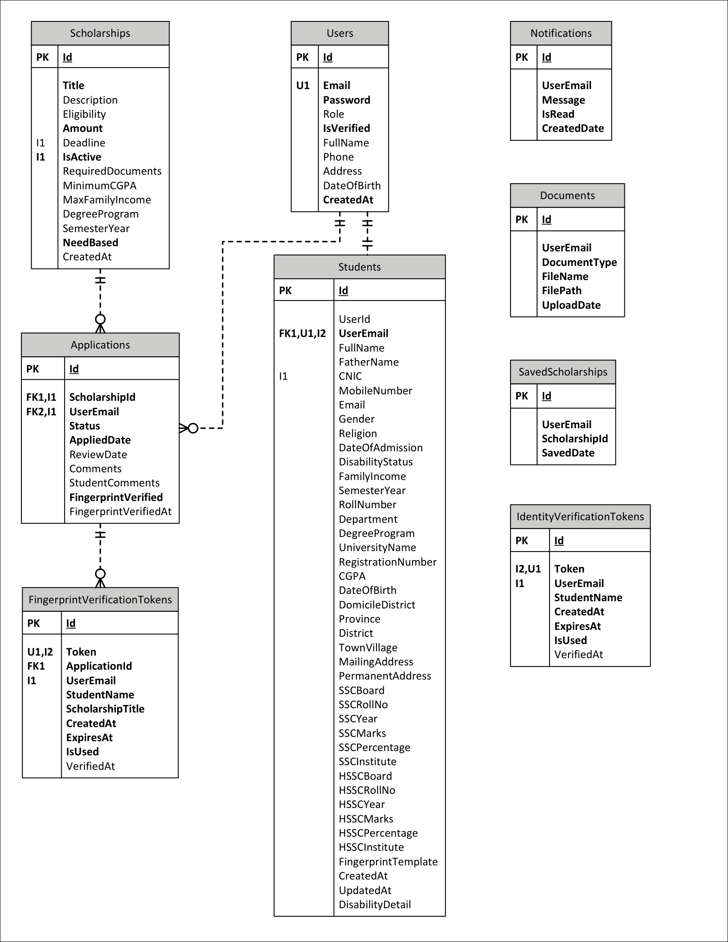

2.5 Tables Converted from ER Diagram

Users
Column | Data Type | Constraints | Notes
Id | INT IDENTITY(1,1) | PRIMARY KEY | Surrogate key
Email | VARCHAR(255) | NOT NULL, UNIQUE | Natural key used as FK in child tables
Password | VARCHAR(255) | NOT NULL | Stored as plain text in dev; should be hashed in production
Role | VARCHAR(50) | DEFAULT 'Student' | 'Student' or 'Admin'
IsVerified | BIT | NOT NULL, DEFAULT 0 | Set to 1 after OTP confirmation
FullName | NVARCHAR(150) | NULL
Phone | VARCHAR(20) | NULL
Address | NVARCHAR(500) | NULL
DateOfBirth | DATETIME | NULL
CreatedAt | DATETIME | NOT NULL, DEFAULT GETDATE()

Students
Column | Data Type | Constraints | Notes
Id | INT IDENTITY(1,1) | PRIMARY KEY
UserId | INT | NULL | Soft link to Users.Id (not enforced by FK)
UserEmail | VARCHAR(255) | NOT NULL, UNIQUE, FK → Users.Email | CASCADE UPDATE/DELETE
FullName | NVARCHAR(150) | NULL
FatherName | NVARCHAR(150) | NULL
CNIC | VARCHAR(20) | NULL | Indexed (filtered)
MobileNumber | VARCHAR(20) | NULL
Gender / Religion | VARCHAR / NVARCHAR | NULL
DateOfAdmission | DATETIME | NULL
DisabilityStatus / DisabilityDetail | NVARCHAR | NULL | Added via ALTER
FamilyIncome | DECIMAL(18,2) | NULL
SemesterYear | VARCHAR(50) | NULL
RollNumber / RegistrationNumber | VARCHAR | NULL
Department / DegreeProgram | NVARCHAR(150) | NULL
UniversityName | NVARCHAR(250) | NULL
CGPA | DECIMAL(3,2) | NULL
DateOfBirth | DATETIME | NULL
DomicileDistrict / Province / District / TownVillage | NVARCHAR | NULL | Address hierarchy
MailingAddress / PermanentAddress | NVARCHAR(500) | NULL
SSCBoard, SSCRollNo, SSCYear, SSCMarks, SSCPercentage, SSCInstitute | Mixed | NULL | Secondary school record
HSSCBoard, HSSCRollNo, HSSCYear, HSSCMarks, HSSCPercentage, HSSCInstitute | Mixed | NULL | Higher secondary record
FingerprintTemplate | VARBINARY(MAX) | NULL | Stores identity-verification marker or biometric template
CreatedAt / UpdatedAt | DATETIME | DEFAULT GETDATE() / NULL | Set on every profile save

Scholarships
Column | Data Type | Constraints | Notes
Id | INT IDENTITY(1,1) | PRIMARY KEY
Title | NVARCHAR(255) | NOT NULL
Description / Eligibility | NVARCHAR(MAX) | NULL | Human-readable eligibility text
Amount | DECIMAL(18,2) | NOT NULL | Award value in PKR (Must be > 0)
Deadline | DATETIME | NULL | Past deadlines blocked for new scholarships
IsActive | BIT | NOT NULL, DEFAULT 1 | Soft delete flag
RequiredDocuments | NVARCHAR(MAX) | NULL | Comma-separated document names
MinimumCGPA | DECIMAL(3,2) | NULL | NULL = no CGPA filter
MaxFamilyIncome | DECIMAL(18,2) | NULL | NULL = no income filter
DegreeProgram | NVARCHAR(150) | NULL | NULL = all programs
SemesterYear | VARCHAR(50) | NULL
NeedBased | BIT | NOT NULL, DEFAULT 0 | Flag for need-based awards
CreatedAt | DATETIME | DEFAULT GETDATE()

Applications
Column | Data Type | Constraints | Notes
Id | INT IDENTITY(1,1) | PRIMARY KEY
ScholarshipId | INT | NOT NULL, FK → Scholarships.Id CASCADE DELETE
UserEmail | VARCHAR(255) | NOT NULL, FK → Users.Email
Status | NVARCHAR(50) | DEFAULT 'Pending' | Pending | Withdrawn | Approved | Rejected
AppliedDate | DATETIME | NOT NULL, DEFAULT GETDATE()
ReviewDate | DATETIME | NULL | Set when admin reviews
Comments | NVARCHAR(MAX) | NULL | Admin notes
StudentComments | NVARCHAR(MAX) | NULL | Applicant personal statement
FingerprintVerified | BIT | NOT NULL, DEFAULT 0 | Set to 1 after mobile verification
FingerprintVerifiedAt | DATETIME2 | NULL | Timestamp of verification

Documents
Column | Data Type | Constraints | Notes
Id | INT IDENTITY(1,1) | PRIMARY KEY
UserEmail | VARCHAR(255) NOT NULL |  | Identifies the owner student
DocumentType | NVARCHAR(120) NOT NULL |  | E.g., 'CNIC', 'Transcript', 'Face Verification', 'Identity Right Thumb Verify'
FileName | NVARCHAR(260) NOT NULL |  | Physical file name on disk
FilePath | NVARCHAR(1000) NOT NULL |  | Absolute path under Uploads/ folder
UploadDate | DATETIME2 NOT NULL | DEFAULT SYSDATETIME()

Notifications
Column | Data Type | Constraints | Notes
Id | INT IDENTITY(1,1) | PRIMARY KEY
UserEmail | VARCHAR(255) NOT NULL |  | Target student
Message | NVARCHAR(500) NOT NULL |  | Notification text
IsRead | BIT NOT NULL | DEFAULT 0
CreatedDate | DATETIME2 NOT NULL | DEFAULT SYSDATETIME()

FingerprintVerificationTokens
Column | Data Type | Constraints / Notes | Notes
Id | INT IDENTITY(1,1) | PRIMARY KEY
Token | NVARCHAR(128) NOT NULL | UNIQUE | 64-char hex token
ApplicationId | INT NOT NULL | FK → Applications.Id | ON DELETE CASCADE
UserEmail | NVARCHAR(255) NOT NULL | Indexed
StudentName | NVARCHAR(255) NOT NULL
ScholarshipTitle | NVARCHAR(255) NOT NULL
CreatedAt | DATETIME2 NOT NULL | DEFAULT SYSDATETIME()
ExpiresAt | DATETIME2 NOT NULL |  | Set to CreatedAt + 1 hour
IsUsed | BIT NOT NULL | DEFAULT 0 | Claimed atomically to prevent race conditions
VerifiedAt | DATETIME2 | NULL | Set when student completes verification

IdentityVerificationTokens
Column | Data Type | Constraints | Notes
Id | INT IDENTITY(1,1) | PRIMARY KEY
Token | NVARCHAR(128) NOT NULL | UNIQUE | 64-char hex token
UserEmail | NVARCHAR(255) NOT NULL | Indexed | Identifies the student
StudentName | NVARCHAR(255) NOT NULL
CreatedAt | DATETIME2 NOT NULL | DEFAULT SYSDATETIME()
ExpiresAt | DATETIME2 NOT NULL |  | Set to CreatedAt + 1 hour
IsUsed | BIT NOT NULL | DEFAULT 0
VerifiedAt | DATETIME2 | NULL

SavedScholarships
Column | Data Type | Constraints / Notes | Notes
Id | INT IDENTITY(1,1) | PRIMARY KEY
UserEmail | VARCHAR(255) NOT NULL | FK (implicit) → Users.Email
ScholarshipId | INT NOT NULL | FK (implicit) → Scholarships.Id
SavedDate | DATETIME2 NOT NULL | DEFAULT SYSDATETIME()

CHAPTER TWO — 3NF, Forms & Reports

3.1 Tables After Third Normal Form (3NF)
All tables in QuasarEdu satisfy the Third Normal Form requirements.
The table below summarizes each table's candidate keys and confirms 3NF compliance:
Table | Primary Key | Candidate / Alternate Keys | 3NF Notes
Users | Id | Email (UNIQUE) | All columns describe the user directly
Students | Id | UserEmail (UNIQUE) | Academic/financial columns depend on the student, not on each other
Scholarships | Id | Title (effectively unique per active listing) | All eligibility columns are properties of the scholarship itself
Applications | Id | (UserEmail, ScholarshipId) — unique for active statuses | Status, dates, and comments all depend on the specific application
Documents | Id | None additional | FileName and FilePath describe the specific document record
SavedScholarships | Id | (UserEmail, ScholarshipId) | SavedDate depends on the bookmark, not on either FK separately
Notifications | Id | None additional | Message, IsRead, CreatedDate depend on the notification
FingerprintVerificationTokens | Id | Token (UNIQUE) | All columns describe the token; ApplicationId is a pure FK
IdentityVerificationTokens | Id | Token (UNIQUE) | All columns describe the token record

Each table is presented below in its final normalised form. Notation: PK = Primary Key, FK = Foreign Key, UQ = Unique, NN = Not Null.

Table 1 — Users
Relation: Users (Id, Email, Password, Role, IsVerified, FullName, Phone, Address, DateOfBirth, CreatedAt)
Attribute | Domain / Data Type | Key | Constraint | Notes
Id | INT IDENTITY(1,1) | PK | NN | Auto-increment surrogate key
Email | VARCHAR(255) | UQ | NN | Used as FK in all child tables
Password | VARCHAR(255) |  | NN
Role | VARCHAR(50) |  | DEFAULT 'Student' | 'Student' | 'Admin'
IsVerified | BIT |  | NN, DEFAULT 0 | 1 after email OTP confirmed
FullName | NVARCHAR(150) |  | NULL
Phone | VARCHAR(20) |  | NULL
Address | NVARCHAR(500) |  | NULL
DateOfBirth | DATETIME |  | NULL
CreatedAt | DATETIME |  | NN, DEFAULT GETDATE()

Table 2 — Students
Relation: Students (Id, UserId, UserEmail [FK→Users.Email], FullName, FatherName, CNIC, MobileNumber, Email, Gender, Religion, DateOfAdmission, DisabilityStatus, DisabilityDetail, FamilyIncome, SemesterYear, RollNumber, Department, DegreeProgram, UniversityName, RegistrationNumber, CGPA, DateOfBirth, DomicileDistrict, Province, District, TownVillage, MailingAddress, PermanentAddress, SSCBoard, SSCRollNo, SSCYear, SSCMarks, SSCPercentage, SSCInstitute, HSSCBoard, HSSCRollNo, HSSCYear, HSSCMarks, HSSCPercentage, HSSCInstitute, FingerprintTemplate, CreatedAt, UpdatedAt)
Attribute | Domain / Data Type | Key | Constraint | Notes
Id | INT IDENTITY(1,1) | PK | NN
UserId | INT |  | NULL | Soft reference to Users.Id
UserEmail | VARCHAR(255) | FK, UQ | NN | → Users(Email) CASCADE UPDATE/DELETE
FullName | NVARCHAR(150) |  | NULL
FatherName | NVARCHAR(150) |  | NULL
CNIC | VARCHAR(20) |  | NULL | Filtered index when NOT NULL
MobileNumber | VARCHAR(20) |  | NULL
Email | VARCHAR(255) |  | NULL | Secondary contact email
Gender | VARCHAR(20) |  | NULL
Religion | NVARCHAR(50) |  | NULL
DateOfAdmission | DATETIME |  | NULL
DisabilityStatus | NVARCHAR(100) |  | NULL
DisabilityDetail | NVARCHAR(300) |  | NULL | Added via ALTER TABLE
FamilyIncome | DECIMAL(18,2) |  | NULL | Annual household income (PKR)
SemesterYear | VARCHAR(50) |  | NULL | e.g. 'Fall 2024'
RollNumber | VARCHAR(50) |  | NULL
Department | NVARCHAR(150) |  | NULL
DegreeProgram | NVARCHAR(150) |  | NULL
UniversityName | NVARCHAR(250) |  | NULL
RegistrationNumber | VARCHAR(100) |  | NULL
CGPA | DECIMAL(3,2) |  | NULL | Range: 0.00 – 4.00
DateOfBirth | DATETIME |  | NULL
DomicileDistrict | NVARCHAR(100) |  | NULL
Province | NVARCHAR(100) |  | NULL
District | NVARCHAR(100) |  | NULL
TownVillage | NVARCHAR(150) |  | NULL
MailingAddress | NVARCHAR(500) |  | NULL
PermanentAddress | NVARCHAR(500) |  | NULL
SSCBoard | NVARCHAR(150) |  | NULL
SSCRollNo | VARCHAR(50) |  | NULL
SSCYear | INT |  | NULL
SSCMarks | DECIMAL(18,2) |  | NULL
SSCPercentage | DECIMAL(5,2) |  | NULL
SSCInstitute | NVARCHAR(250) |  | NULL
HSSCBoard | NVARCHAR(150) |  | NULL
HSSCRollNo | VARCHAR(50) |  | NULL
HSSCYear | INT |  | NULL
HSSCMarks | DECIMAL(18,2) |  | NULL
HSSCPercentage | DECIMAL(5,2) |  | NULL
HSSCInstitute | NVARCHAR(250) |  | NULL
FingerprintTemplate | VARBINARY(MAX) |  | NULL | Stores biometric marker or identity verification string
CreatedAt | DATETIME |  | DEFAULT GETDATE()
UpdatedAt | DATETIME |  | NULL | Set on every profile update

Table 3 — Scholarships
Relation: Scholarships (Id, Title, Description, Eligibility, Amount, Deadline, IsActive, RequiredDocuments, MinimumCGPA, MaxFamilyIncome, DegreeProgram, SemesterYear, NeedBased, CreatedAt)
Attribute | Domain / Data Type | Key | Constraint | Notes
Id | INT IDENTITY(1,1) | PK | NN
Title | NVARCHAR(255) |  | NN | Scholarship name
Description | NVARCHAR(MAX) |  | NULL | Detailed description
Eligibility | NVARCHAR(MAX) |  | NULL | Freeform eligibility text
Amount | DECIMAL(18,2) |  | NN | Award value in PKR
Deadline | DATETIME |  | NULL | NULL = open-ended
IsActive | BIT |  | NN, DEFAULT 1 | 0 = soft deleted / deactivated
RequiredDocuments | NVARCHAR(MAX) |  | NULL | Comma-separated document names
MinimumCGPA | DECIMAL(3,2) |  | NULL | NULL = no CGPA filter
MaxFamilyIncome | DECIMAL(18,2) |  | NULL | NULL = no income filter
DegreeProgram | NVARCHAR(150) |  | NULL | NULL = all programs accepted
SemesterYear | VARCHAR(50) |  | NULL | NULL = any semester
NeedBased | BIT |  | NN, DEFAULT 0 | 1 = need-based award
CreatedAt | DATETIME |  | DEFAULT GETDATE()

Table 4 — Applications
Relation: Applications (Id, ScholarshipId [FK→Scholarships.Id], UserEmail [FK→Users.Email], Status, AppliedDate, ReviewDate, Comments, StudentComments, FingerprintVerified, FingerprintVerifiedAt)
Attribute | Domain / Data Type | Key | Constraint | Notes
Id | INT IDENTITY(1,1) | PK | NN
ScholarshipId | INT | FK | NN | → Scholarships(Id) ON DELETE CASCADE
UserEmail | VARCHAR(255) | FK | NN | → Users(Email)
Status | NVARCHAR(50) |  | NN, DEFAULT 'Pending' | Pending | Under Review | Approved | Rejected
AppliedDate | DATETIME |  | NN, DEFAULT GETDATE()
ReviewDate | DATETIME |  | NULL | Set when admin reviews
Comments | NVARCHAR(MAX) |  | NULL | Admin review notes
StudentComments | NVARCHAR(MAX) |  | NULL | Applicant personal statement
FingerprintVerified | BIT |  | NN, DEFAULT 0 | 1 after mobile verification completed
FingerprintVerifiedAt | DATETIME2 |  | NULL | Timestamp of verification

Table 5 — Documents
Relation: Documents (Id, UserEmail [FK→Users.Email], DocumentType, FileName, FilePath, UploadDate)
Attribute | Domain / Data Type | Key | Constraint | Notes
Id | INT IDENTITY(1,1) | PK | NN
UserEmail | VARCHAR(255) | FK | NN | → Users(Email)
DocumentType | NVARCHAR(120) |  | NN | e.g. 'CNIC Front', 'Face Verification'
FileName | NVARCHAR(260) |  | NN | Name of the stored file
FilePath | NVARCHAR(1000) |  | NN | Absolute path on server disk
UploadDate | DATETIME2 |  | NN, DEFAULT SYSDATETIME()

Table 6 — SavedScholarships
Relation: SavedScholarships (Id, UserEmail [FK→Users.Email], ScholarshipId [FK→Scholarships.Id], SavedDate)
Attribute | Domain / Data Type | Key | Constraint | Notes
Id | INT IDENTITY(1,1) | PK | NN
UserEmail | VARCHAR(255) | FK | NN | → Users(Email)
ScholarshipId | INT | FK | NN | → Scholarships(Id)
SavedDate | DATETIME2 |  | NN, DEFAULT SYSDATETIME() | Timestamp of bookmark creation

Table 7 — Notifications
Relation: Notifications (Id, UserEmail [FK→Users.Email], Message, IsRead, CreatedDate)
Attribute | Domain / Data Type | Key | Constraint | Notes
Id | INT IDENTITY(1,1) | PK | NN
UserEmail | VARCHAR(255) | FK | NN | → Users(Email); notification recipient
Message | NVARCHAR(500) |  | NN | Notification body text
IsRead | BIT |  | NN, DEFAULT 0 | 0 = unread; 1 = read
CreatedDate | DATETIME2 |  | NN, DEFAULT SYSDATETIME()

Table 8 — FingerprintVerificationTokens
Relation: FingerprintVerificationTokens (Id, Token, ApplicationId [FK→Applications.Id], UserEmail, StudentName, ScholarshipTitle, CreatedAt, ExpiresAt, IsUsed, VerifiedAt)
Attribute | Domain / Data Type | Key | Constraint | Notes
Id | INT IDENTITY(1,1) | PK | NN
Token | NVARCHAR(128) | UQ | NN | Cryptographically random token (GUID-based)
ApplicationId | INT | FK | NN | → Applications(Id) ON DELETE CASCADE
UserEmail | NVARCHAR(255) |  | NN | Denormalised for quick lookup without join
StudentName | NVARCHAR(255) |  | NN | Denormalised for email template
ScholarshipTitle | NVARCHAR(255) |  | NN | Denormalised for email template
CreatedAt | DATETIME2 |  | NN, DEFAULT SYSDATETIME()
ExpiresAt | DATETIME2 |  | NN | CreatedAt + 48 hours
IsUsed | BIT |  | NN, DEFAULT 0 | 1 after student completes verification
VerifiedAt | DATETIME2 |  | NULL | Timestamp when IsUsed was set to 1

Table 9 — IdentityVerificationTokens
Relation: IdentityVerificationTokens (Id, Token, UserEmail, StudentName, CreatedAt, ExpiresAt, IsUsed, VerifiedAt)
Attribute | Domain / Data Type | Key | Constraint | Notes
Id | INT IDENTITY(1,1) | PK | NN
Token | NVARCHAR(64) | UQ | NN | Single-use random token
UserEmail | NVARCHAR(255) |  | NN | Target student's email
StudentName | NVARCHAR(255) |  | NN | For mobile verification page display
CreatedAt | DATETIME2 |  | NN, DEFAULT SYSDATETIME()
ExpiresAt | DATETIME2 |  | NN | CreatedAt + 48 hours
IsUsed | BIT |  | NN, DEFAULT 0 | 1 after identity verification completed
VerifiedAt | DATETIME2 |  | NULL | Timestamp of completion

3.3 Forms & Form Layouts

Form 1 — Loading
Purpose: Display an animated splash screen while the application initialises and transitions to Login.
Field / Control | Type | Validation / Notes
Progress Bar (progressBar1) | ProgressBar | Range 0–100; advances by 3 per tick; auto-starts on Form_Load
Percentage Label (lblPercent) | Label | Updates each tick displaying the current value as “xx %”
Timer (timer1) | Timer | Interval: 100 ms; stops when bar reaches maximum; hides Loading form and opens Login

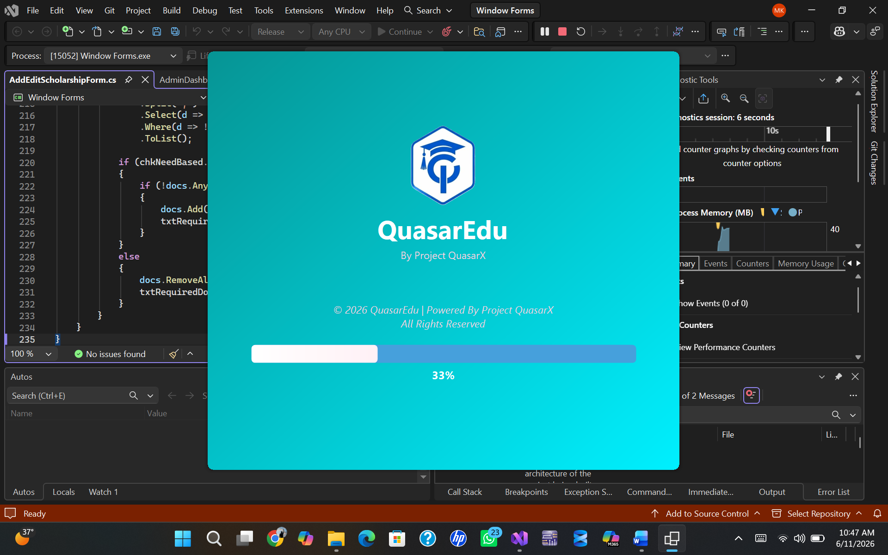

Form 2 — Login
Purpose: Authenticate an existing user and route them to the correct dashboard.
Field / Control | Type | Validation / Notes
Email | TextBox | Must be non-empty, valid email format
Password | TextBox (masked) | Must be non-empty
Login Button | Button | Queries Users table; checks IsVerified flag; loads Session
Register Link | LinkLabel | Navigates to Register form
Forgot Password Link | LinkLabel | Navigates to Forgot Password form

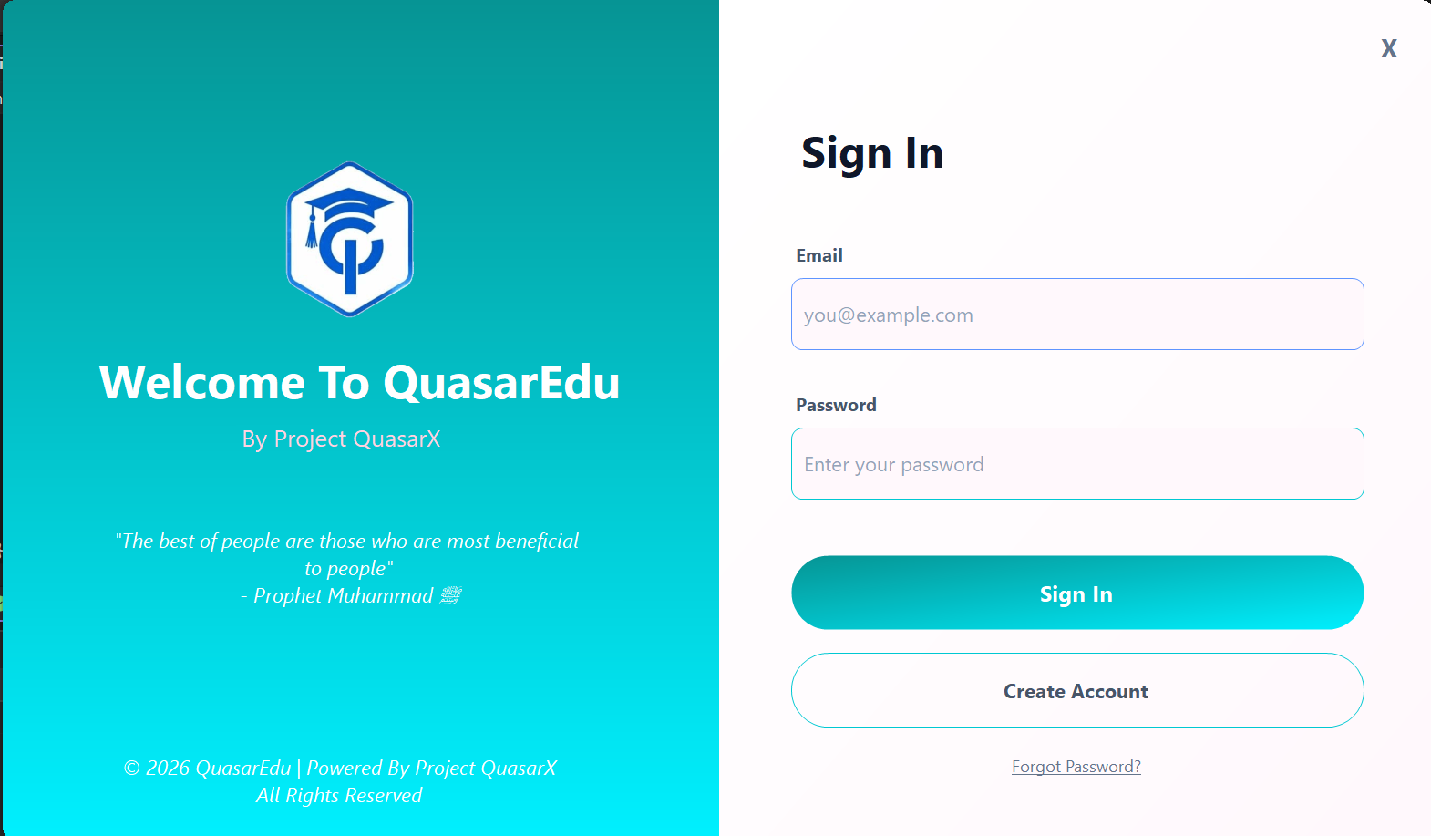

Form 3 — Register
Purpose: Create a new student account and trigger OTP email.
Field / Control | Type | Validation / Notes
Full Name | TextBox | Required, NVARCHAR(150)
Email | TextBox | Required, unique, triggers duplicate-check on Register
Password | TextBox (masked) | Required
Confirm Password | TextBox (masked) | Must match Password
Register Button | Button | Inserts into Users; sends 6-digit OTP via Gmail SMTP; opens OTP form

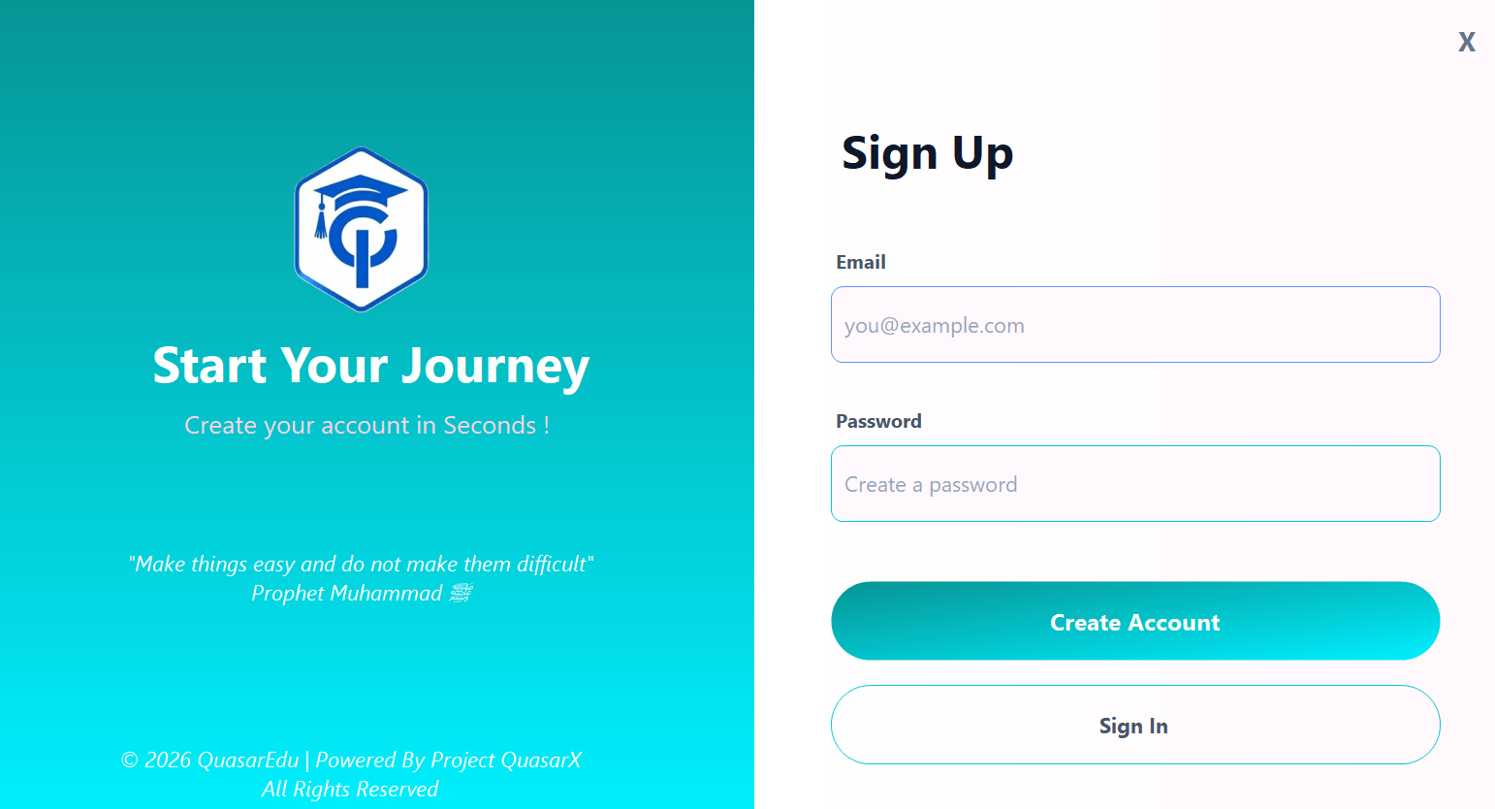

Form 4 — OTP Verification
Purpose: Verify that the email address belongs to the registrant.
Field / Control | Type | Notes
OTP Input (6 separate boxes) | 6 × TextBox | Each box accepts one digit; auto-advances focus
Verify Button | Button | Compares entered code against the one sent; sets IsVerified = 1 on match
Resend OTP Link | LinkLabel | Sends a fresh code and resets the timer
Countdown Timer | Label | Shows seconds remaining (5-minute window)

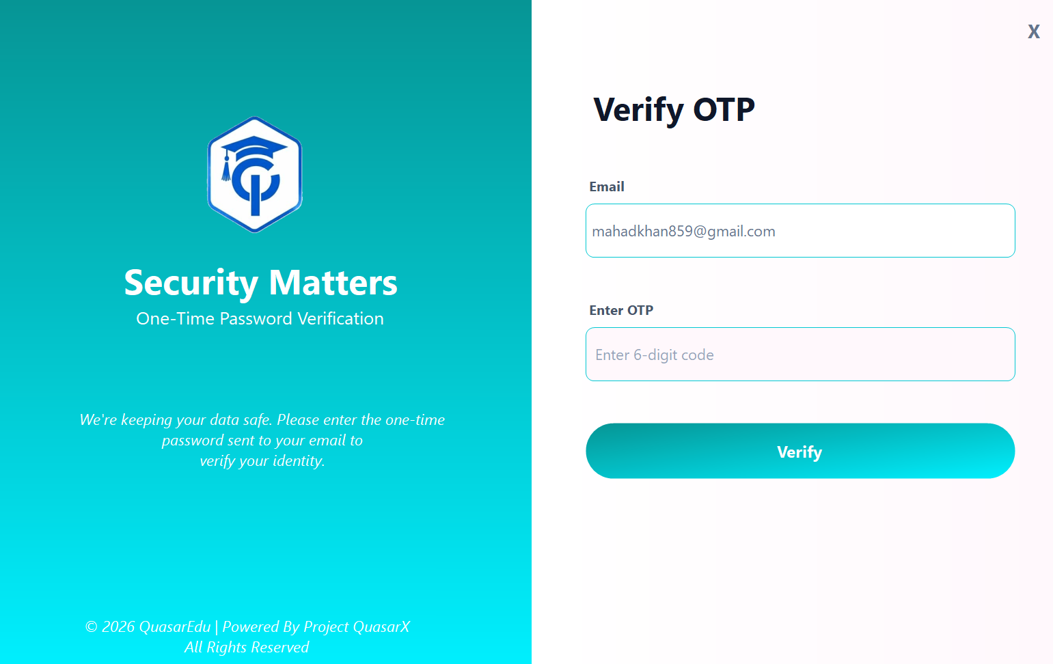

Form 5 — Student Dashboard
Purpose: Central hub for student navigation and overview stats.
Section / Control | Type | Description
Welcome Banner | Label + Panel | Displays student name and identity verification status badge
Stats Row | 4 × Panel | Total scholarships, Applications submitted, Approved count, Pending count
Navigation Sidebar | Button strip | Links: Profile | Browse Scholarships | My Applications | Documents | Notifications | Logout
Scholarship Cards | DataGridView / Panel list | Shows top eligible scholarships with Apply and Save buttons
Notification Bell | PictureBox + Badge | Unread notification count overlay

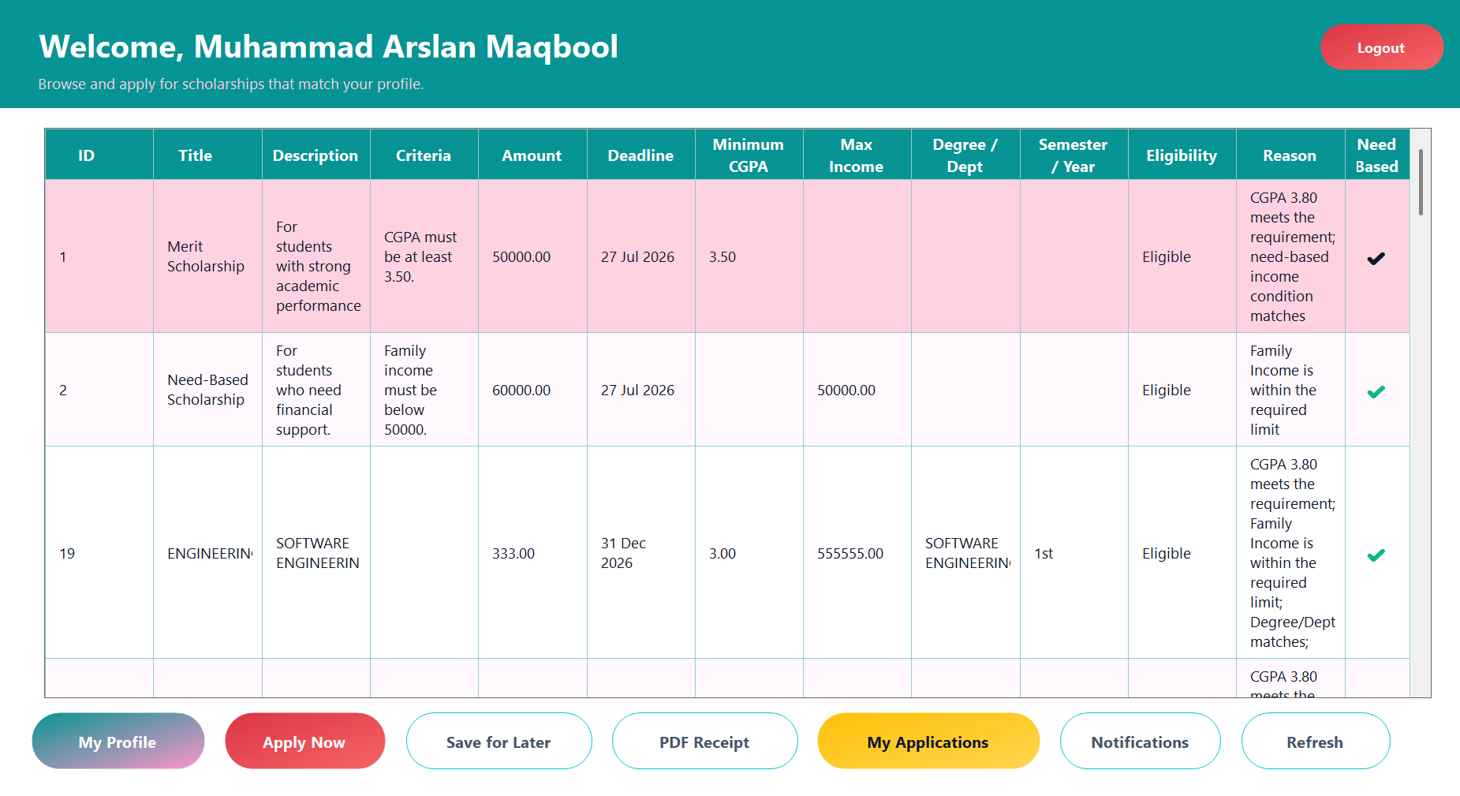

Form 6 — Student Profile
Purpose: Allow students to fill in and update all personal, academic, and financial data required for eligibility evaluation.
Tab / Section | Fields
Personal Info | Full Name, Father Name, CNIC, Mobile, Gender, Religion, DOB, Disability Status & Detail
Address | Domicile District, Province, District, Town/Village, Mailing Address, Permanent Address
Academic — University | University Name, Registration No., Roll Number, Department, Degree Program, Semester/Year, CGPA, Date of Admission
Academic — SSC | Board, Roll No., Year, Marks, Percentage, Institute
Academic — HSSC | Board, Roll No., Year, Marks, Percentage, Institute
Financial | Family Income (PKR)
Biometric | Fingerprint Template status badge; displays VERIFIED or NOT VERIFIED

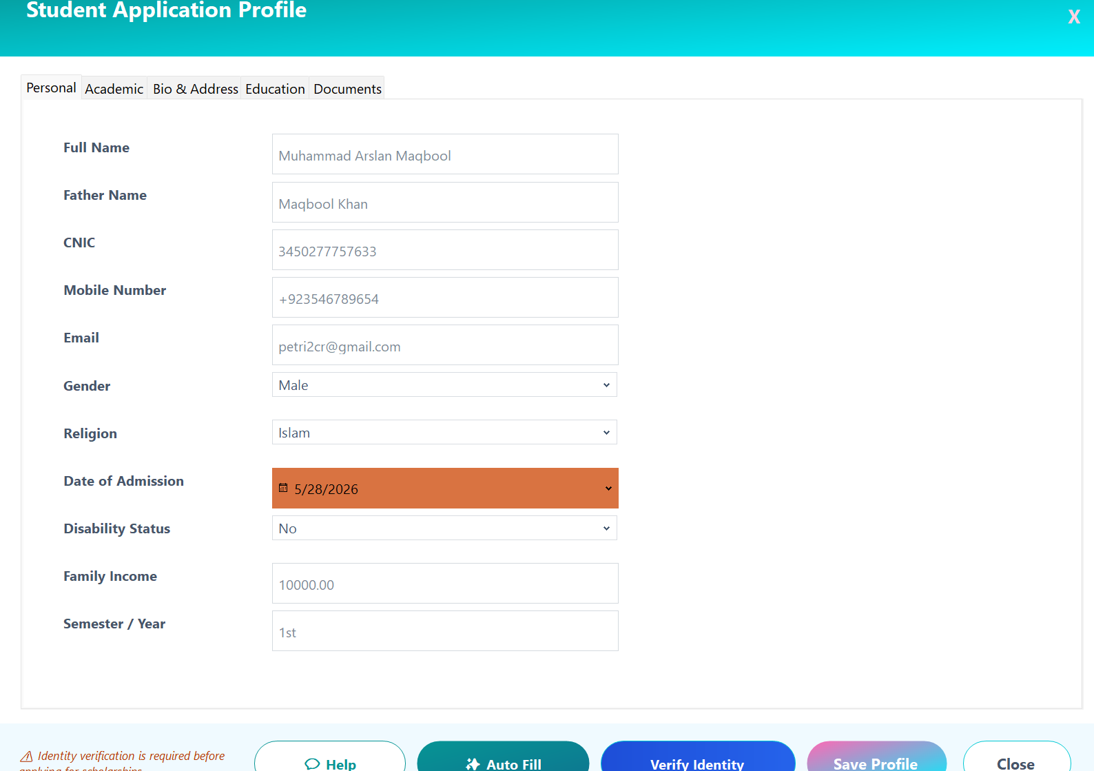

Form 7 — Apply for Scholarship
Purpose: Let an eligible student submit an application for a specific scholarship.
Control | Type | Notes
Scholarship Details Panel | Read-only Labels | Title, Amount, Deadline, Eligibility, Required Documents
Personal Statement / Comments | MultiLine TextBox | Optional; stored as StudentComments
Document Checklist | CheckedListBox | Lists required documents; links to Document Upload form
Submit Application Button | Button | Calls sp_SubmitApplication; shows result message
Save Scholarship Button | Button | Adds to SavedScholarships if not already bookmarked

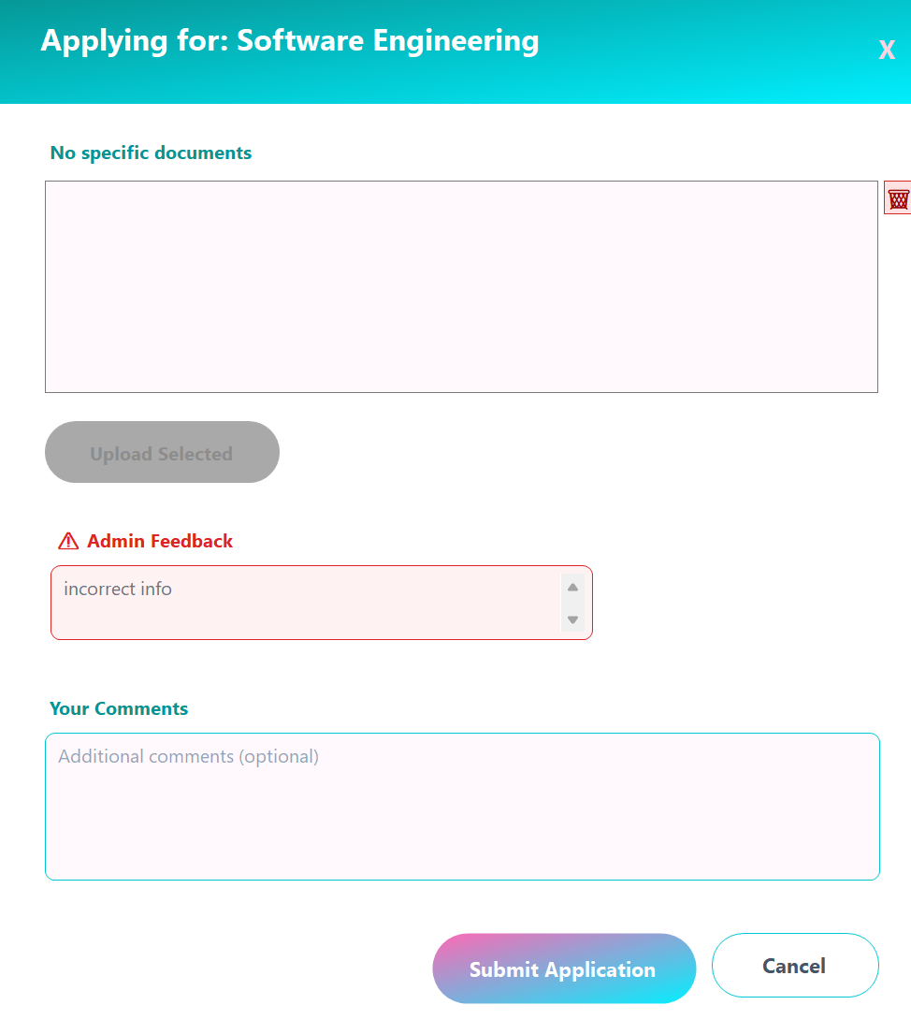

Form 8 — My Applications
Purpose: Display all past and current applications of the logged-in student.
Column Displayed | Source | Notes
Scholarship Title | Scholarships.Title
Amount (PKR) | Scholarships.Amount | Formatted with comma separator
Status | Applications.Status | Colour-coded: green=Approved, red=Rejected, amber=Pending
Applied Date | Applications.AppliedDate | dd-MMM-yyyy format
Admin Comments | Applications.Comments
Fingerprint Verified | Applications.FingerprintVerified | Tick / Cross icon
Print Receipt Button | Button per row | Opens printable receipt via ApplicationReceiptService

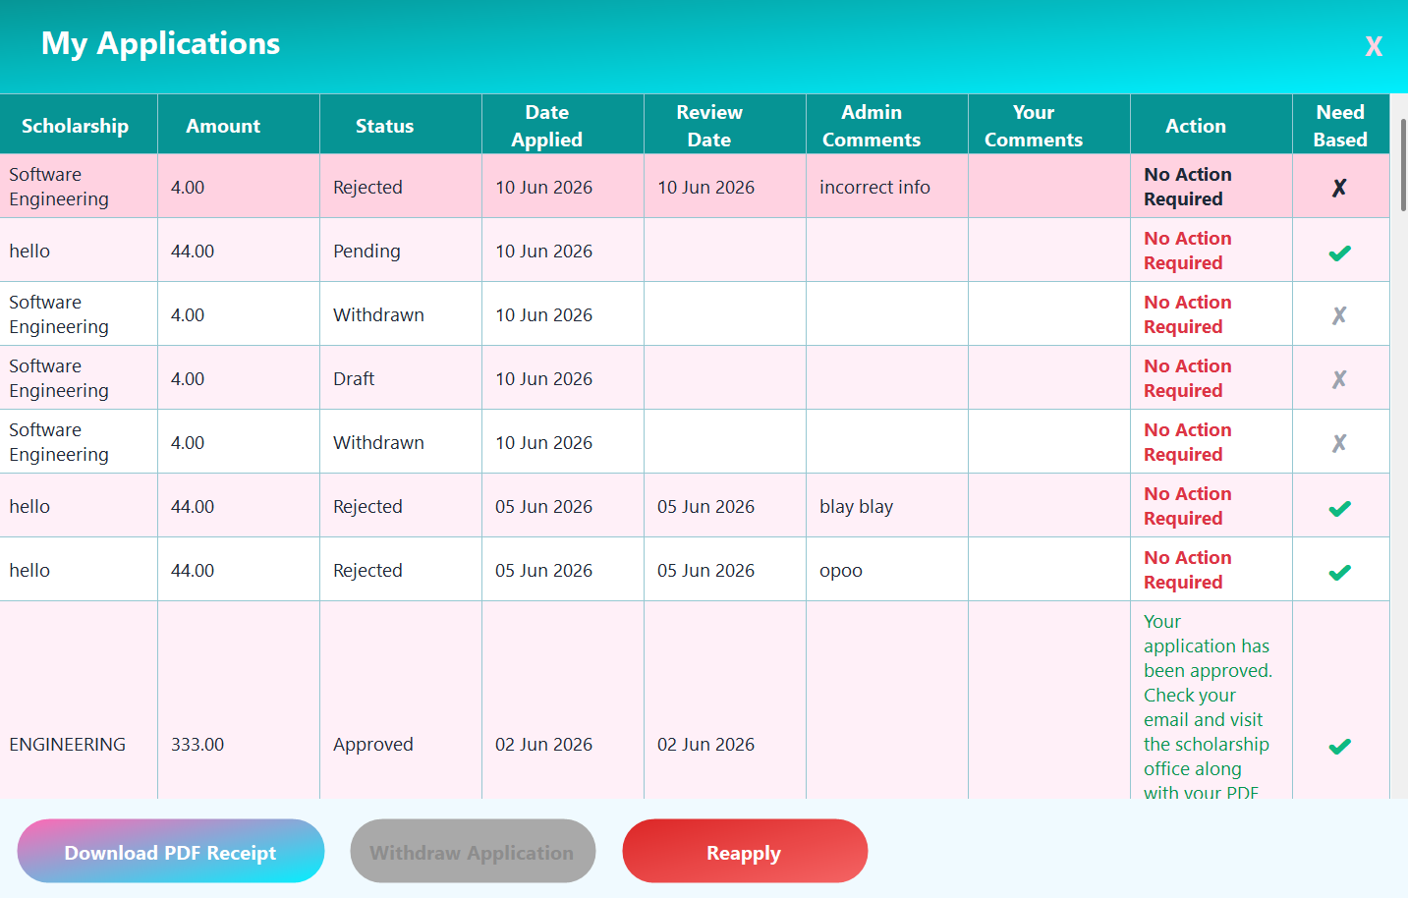

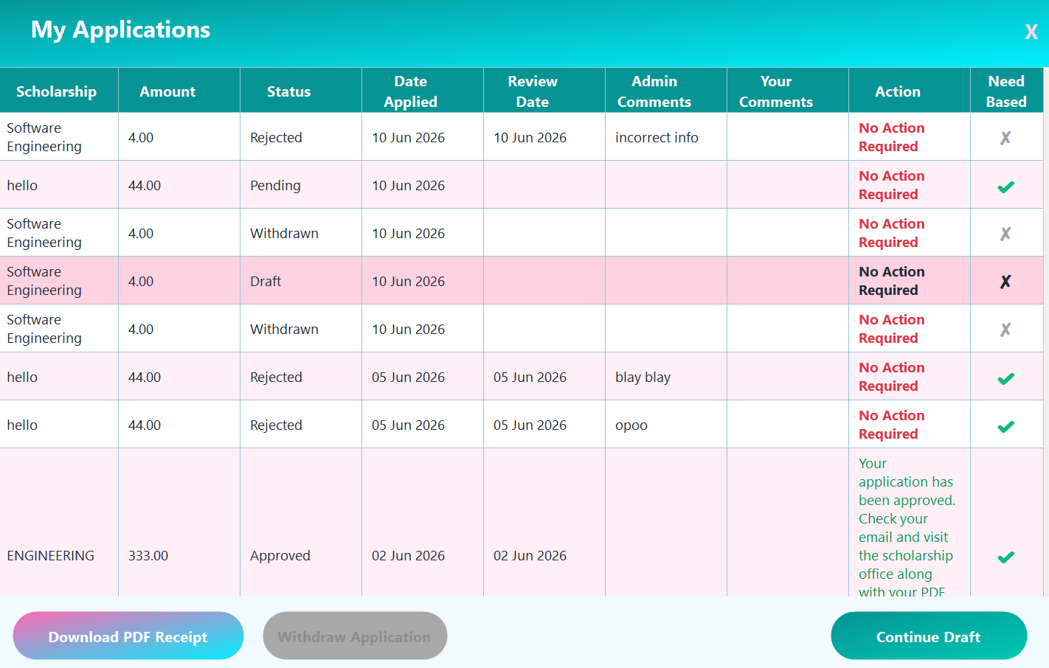

Form 9 — Admin Dashboard
Purpose: Provide administrators with a complete operational overview.
Section | Description
KPI Tiles | Total students, total scholarships, pending applications, approved applications
Scholarships Tab | DataGridView with Add / Edit / Deactivate buttons
Applications Tab | DataGridView of all applications; filter by status; double-click to review
Students Tab | DataGridView of all registered students; click to open StudentProfilePopup
Documents Tab | Opens AllDocumentsForm with all student-uploaded files
Notifications Panel | Send notification to all or specific user

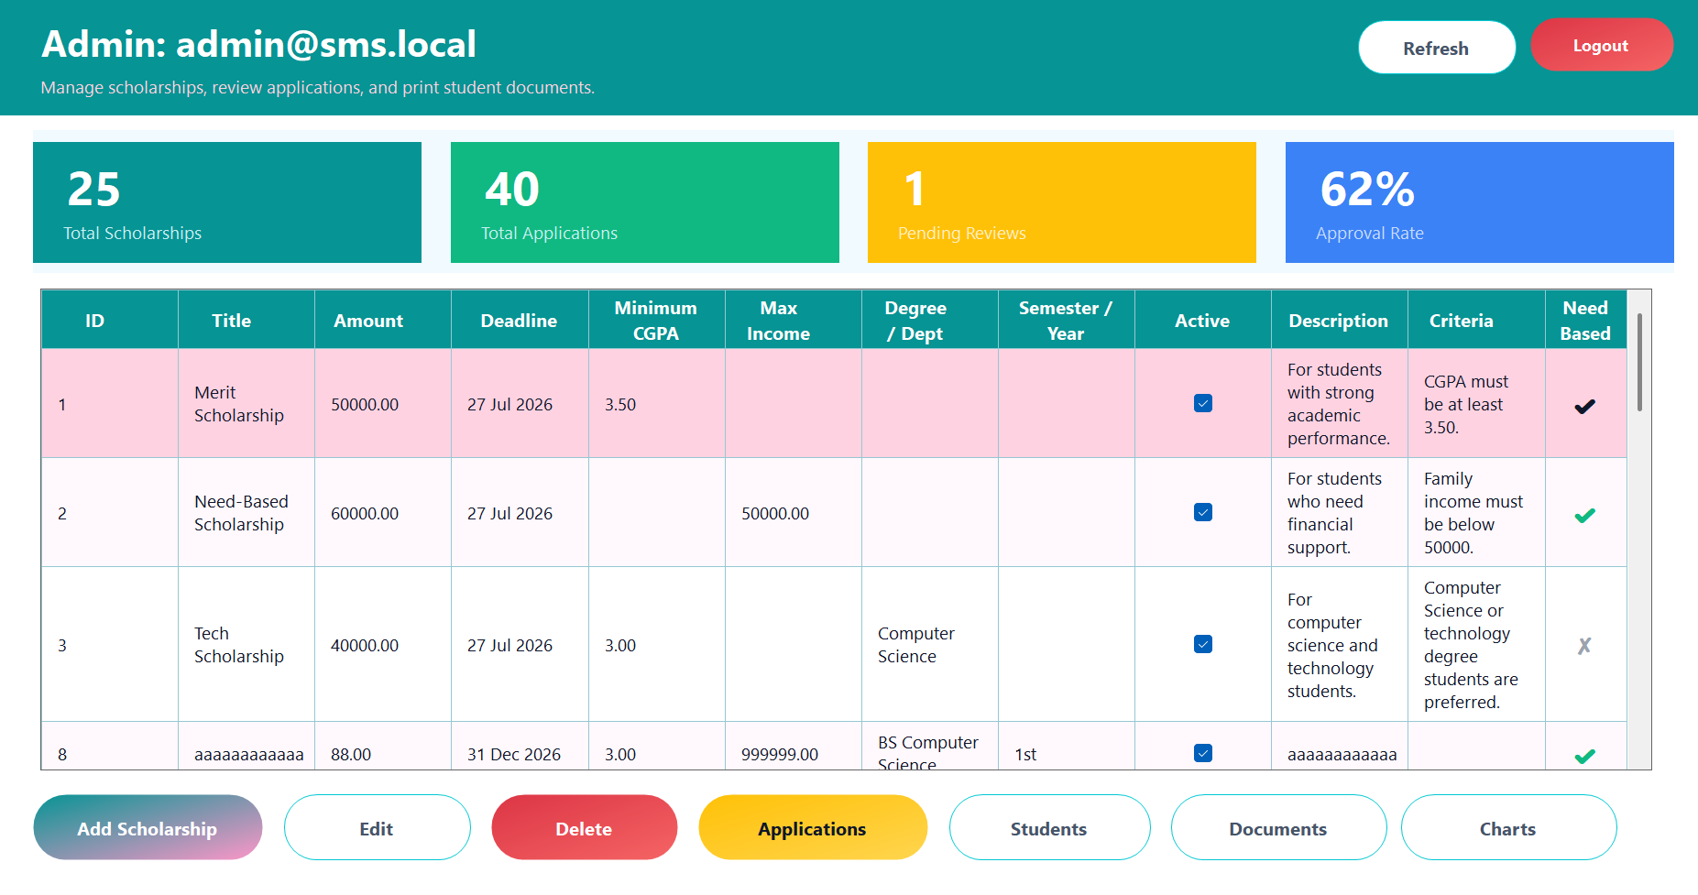

Form 10 — Approve / Reject Application
Purpose: Allow an admin to set an application status and optionally send a verification link.
Control | Type | Notes
Application Details | Read-only Labels | Student name, scholarship, amount, applied date
Status Selector | ComboBox | Approved | Rejected | Withdrawn
Admin Comments | MultiLine TextBox | Stored in Applications.Comments
Save Decision Button | Button | Calls sp_UpdateApplicationStatus

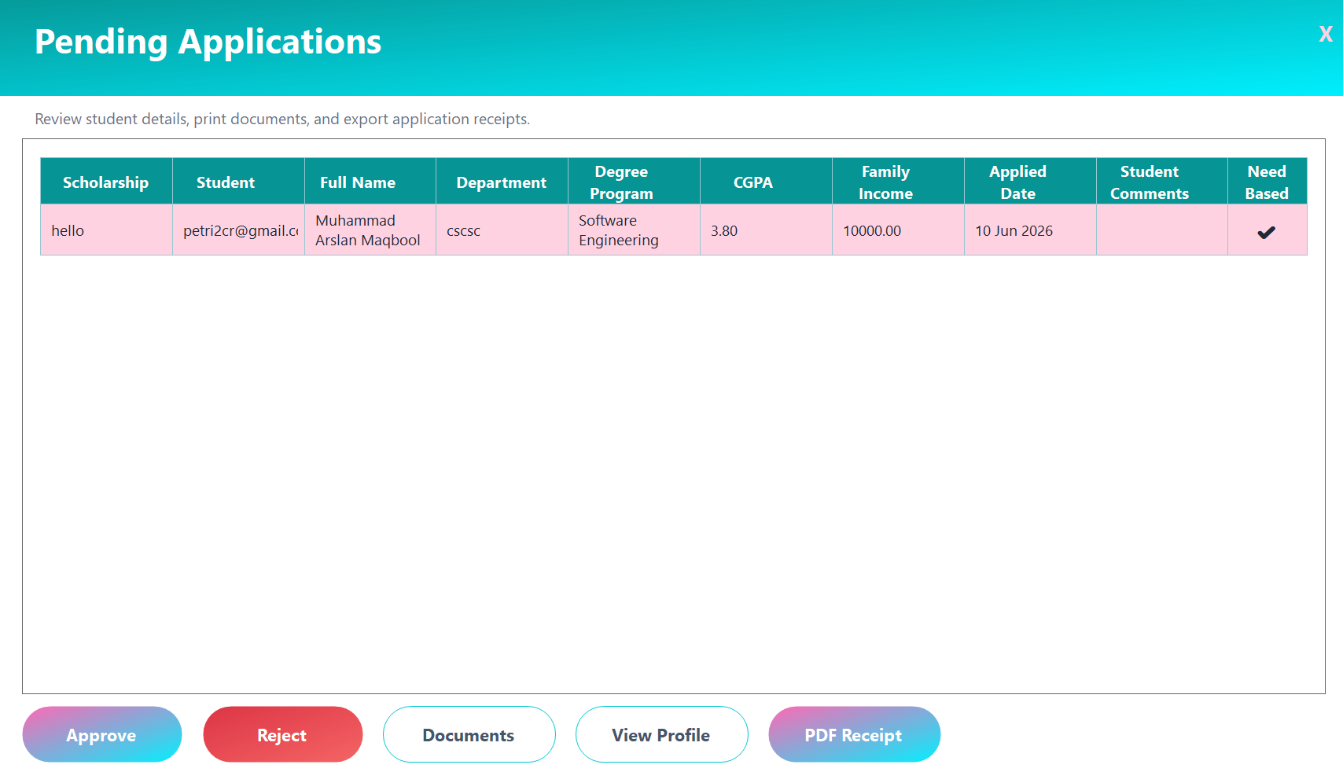

Form 11 — Add / Edit Scholarship
Purpose: Create or modify a scholarship record.
Field | Type | Notes
Title | TextBox | Required, up to 255 chars
Description / Eligibility | MultiLine TextBox | Rich text guidance for applicants
Amount | NumericUpDown | PKR, decimal 2 places
Deadline | DateTimePicker | Optional; leave blank for open-ended
Minimum CGPA | NumericUpDown | Optional filter (0.00 – 4.00)
Max Family Income | NumericUpDown | Optional filter
Degree Program | TextBox | Optional; NULL = any program
Semester / Year | TextBox | Optional
Need-Based | CheckBox | Marks scholarship as need-based
Required Documents | MultiLine TextBox | Comma-separated list
Is Active | CheckBox | Soft-delete flag
Save Button | Button | INSERT or UPDATE via sp_CreateScholarship or direct SQL

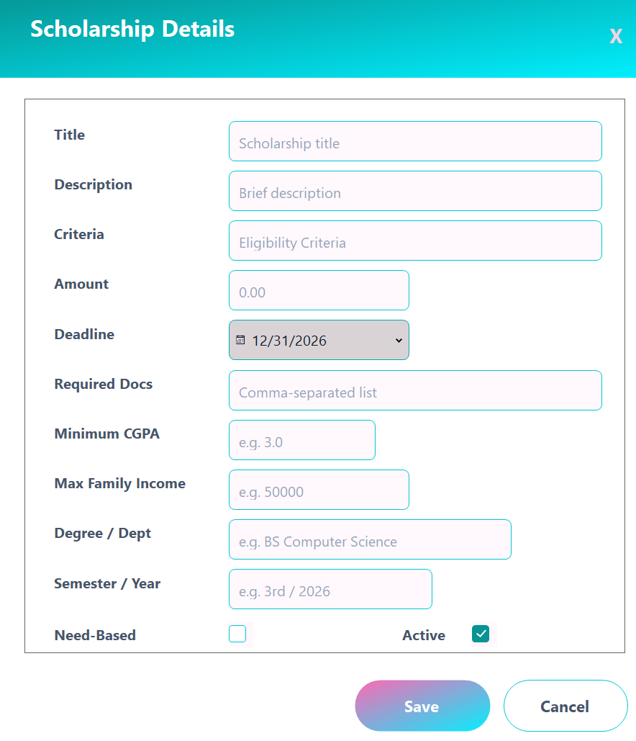

Form 12 — Notifications
Purpose: Display the student's notification inbox.
Control | Description
Notification List | Panel-based list; unread rows highlighted in light blue; read rows in white
Mark All Read Button | Sets IsRead = 1 for all unread notifications of the current user
Notification Count Badge | Shown on dashboard; updates live on form open

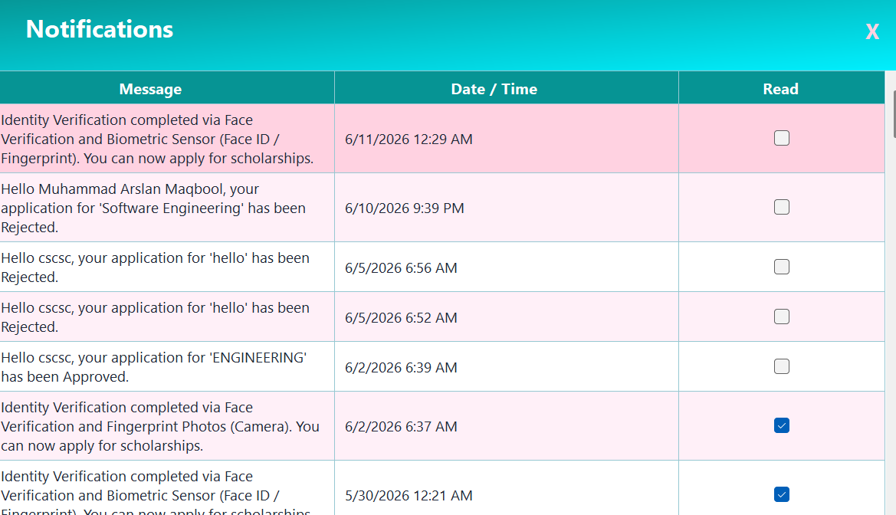

Form 13 — Document Upload / Viewer
Purpose: Upload and review documents associated with scholarship applications.
Control | Description
Document Type Selector | ComboBox listing required document types from the active scholarship
File Browse Button | OpenFileDialog filtered to image and PDF formats
Preview Panel | PictureBox showing image thumbnail or file name for PDFs
Upload Button | Saves file to server upload folder, inserts row in Documents table
Uploaded Documents Grid | DataGridView listing all documents for the user with type and upload date
View Button (per row) | Opens the file in the default OS viewer

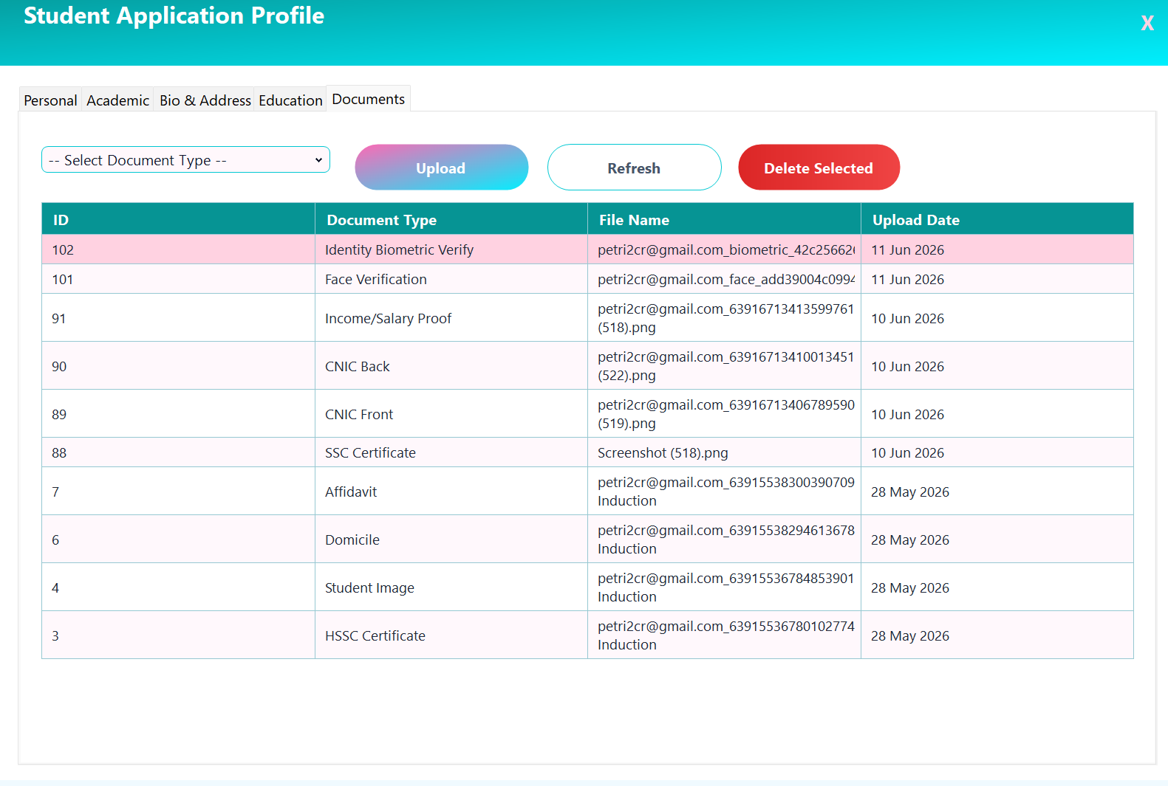

Form 14 — Forgot Password
Purpose: Allow users to reset their password via a 6-digit email OTP flow.
Field / Control | Type | Validation / Notes
Email (txtEmail) | TextBox | Required; valid email regex; locked after OTP dispatch to prevent email-swap attacks
Send OTP Button (btnSendOtp) | Button | Checks email in Users table; generates OTP; sends via Gmail SMTP; sets 5-minute expiry; hides itself
OTP (txtOtp) | TextBox | Visible only after OTP dispatch; max 3 attempts; OTP expires after 5 minutes
New Password (txtNewPassword) | TextBox (masked) | Required; minimum 6 characters
Confirm Password (txtConfirmPassword) | TextBox (masked) | Must match New Password exactly
Reset Password (btnResetPassword) | Button | Verifies attempt limit and expiry; BCrypt-hashes new password; UPDATEs Users.Password; closes form
Cancel (btnCancel) | Button | Closes the form with no changes

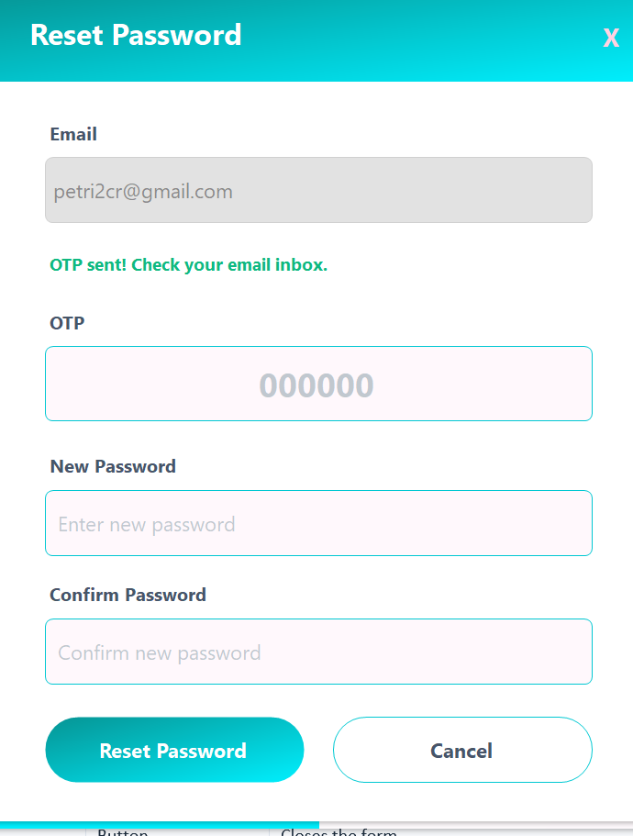

Form 15 — Student List
Purpose: Provide administrators with a searchable, filterable list of all registered students.
Field / Control | Type | Validation / Notes
Search Box (txtSearch) | TextBox | LIKE filter across FullName, CNIC, Department, DegreeProgram, UserEmail
Max Income (txtMaxIncome) | TextBox | Restricts results to FamilyIncome ≤ value; numeric validation before query
Min CGPA (txtMinCgpa) | TextBox | Restricts results to CGPA ≥ value; numeric validation before query
Filter (btnFilter) | Button | Re-executes the SQL query with current filter values applied
Clear (btnClear) | Button | Resets all filter fields and reloads the full student list
Student Grid (dgvStudents) | DataGridView | Read-only; columns: Email, Full Name, CNIC, Mobile Number, Department, Degree Program, Semester / Year, CGPA, Family Income, Province, District; sorted by FullName then UserEmail
Row Double-Click | Event | Opens StudentProfilePopupForm modal for the selected row’s email
Close (btnClose) | Button | Closes the form

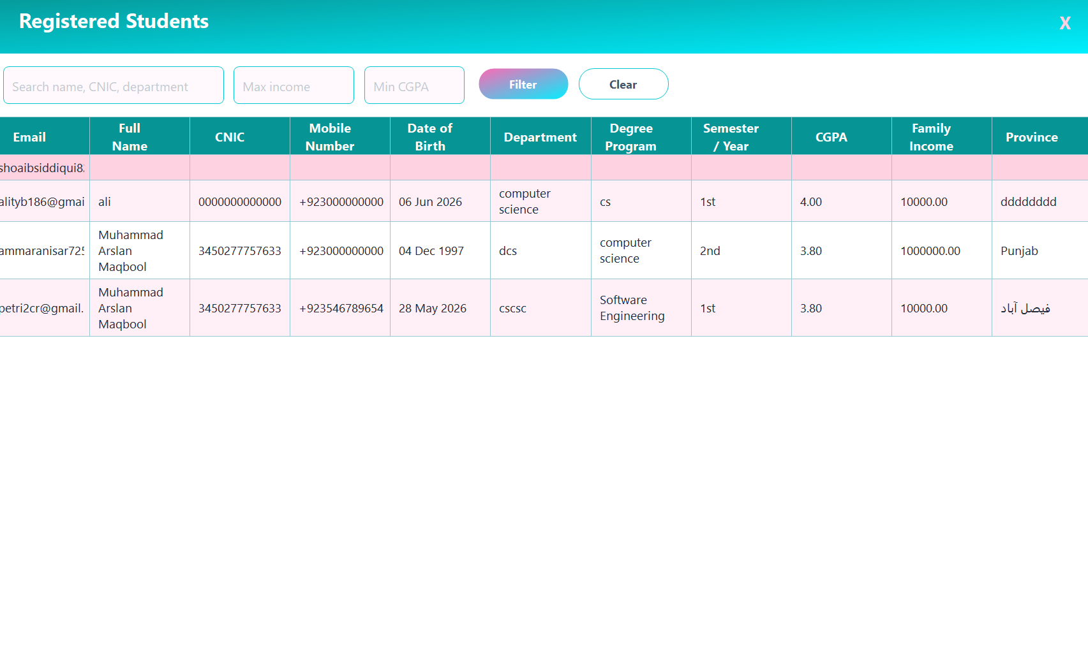

Form 16 — Student Profile Popup
Purpose: Display a read-only field-value grid of a student’s complete profile in a modal dialog.
Field / Control | Type | Validation / Notes
Header Label (lblHeaderTitle) | Label | Caption: “Student Profile — <email>”
Profile Grid (dgvProfile) | DataGridView | Two columns (Field | Value); Field fixed at 220 px; Value auto-fills remaining width; read-only
Identity Verification Row | Derived field | ✓ Identity Verified or ✘ Not Verified, derived from FingerprintTemplate byte array
Disability Status Row | Derived field | Combines DisabilityStatus + DisabilityDetail into a single readable display string
Date Formatting | Display rule | All DateTime values rendered as dd MMM yyyy (e.g. 05 Jun 2026)
Friendly Field Names | Display rule | Column names mapped to labels; e.g. UserEmail → Email, DegreeProgram → Degree Program
Excluded Columns | Display rule | Id, UserId, CreatedAt, UpdatedAt, DisabilityDetail are hidden from the grid
Close (btnClose) | Button | Dismisses the modal dialog

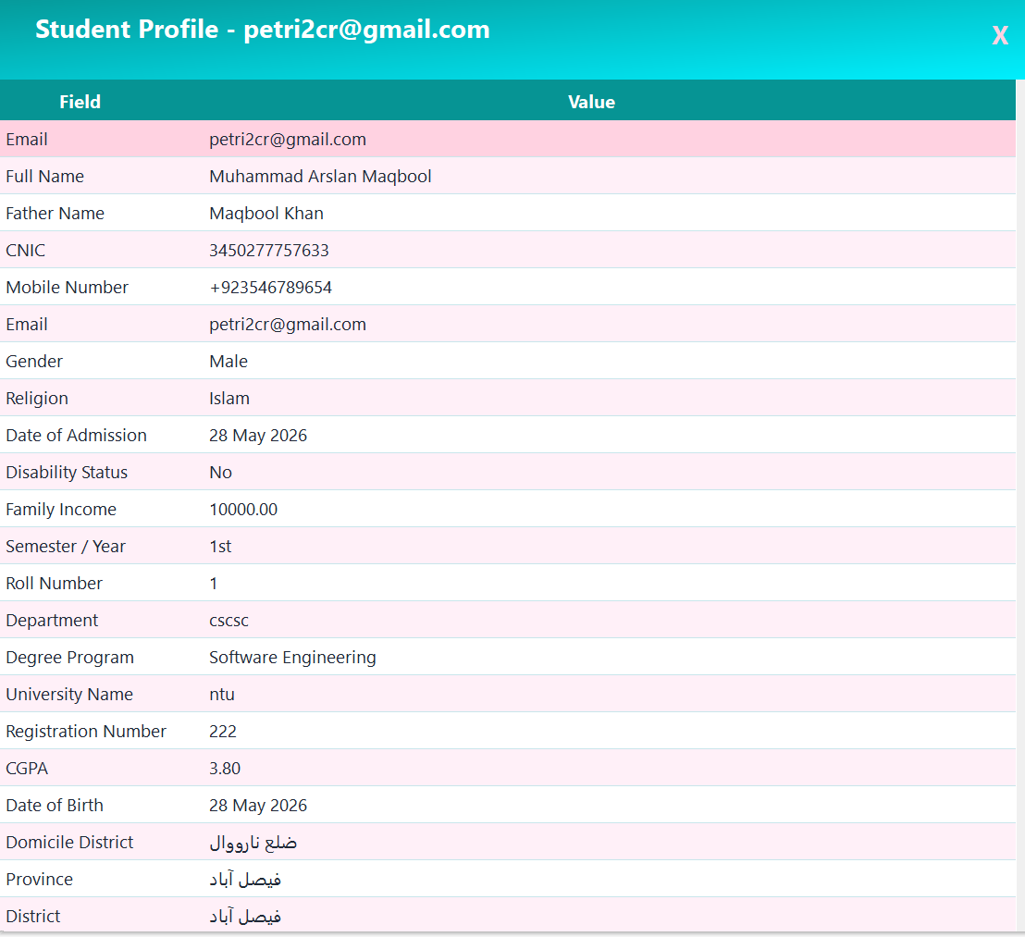

Form 17 — All Documents Form
Purpose: View, open, and print uploaded documents; supports admin (all students) and per-student contexts.
Field / Control | Type | Validation / Notes
Header Label (lblHeaderTitle) | Label | “Documents — <email>” in student mode; generic title in admin mode
Document Grid (dgvDocuments) | DataGridView | Read-only; columns: Student (hidden in single-student view), Document Type, File Name, Upload Date; Id and FilePath columns hidden; sorted by UploadDate DESC
Upload Date Column | DataGridViewColumn | Formatted as dd MMM yyyy
Open (btnOpen) | Button | Verifies file exists on disk; opens in default OS viewer via DocumentPrintService.OpenDocument
Print (btnPrint) | Button | Verifies file exists on disk; sends to default printer via DocumentPrintService.PrintDocument
No Selection Guard | Validation | ShowInfo toast prompts user to select a document first if no row is selected
File-not-found Guard | Validation | ShowError toast if FilePath does not exist on disk before Open or Print
Close (btnClose) | Button | Closes the form

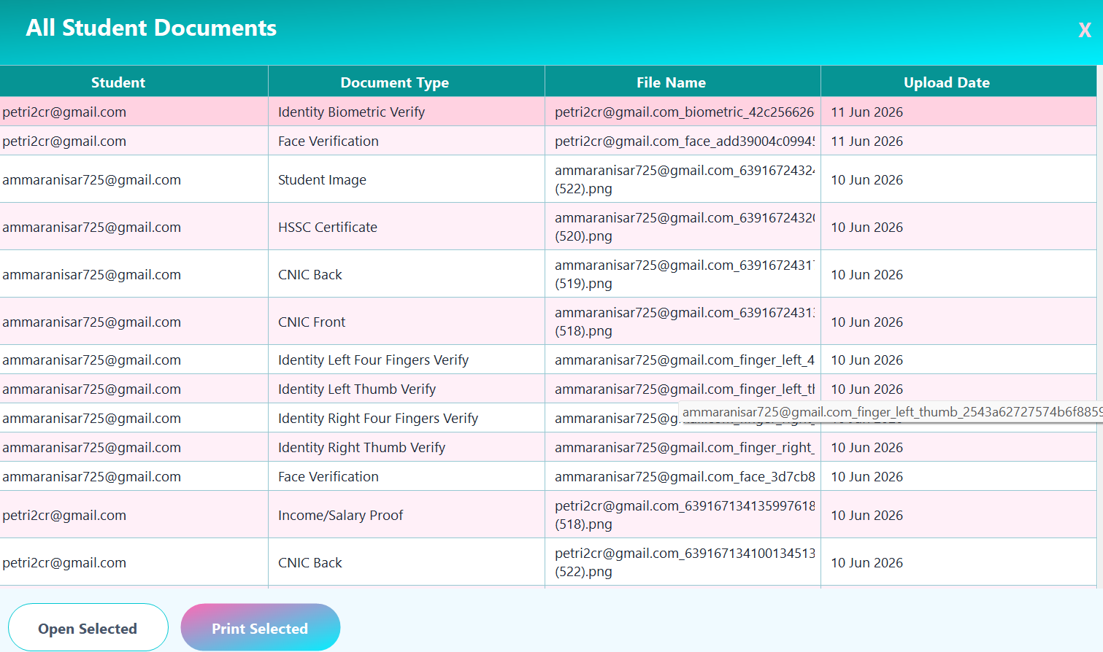

Form 18 — Toast Notification Form
Purpose: Render non-blocking, auto-dismissing overlay notifications in four severity variants.
Field / Control | Type | Validation / Notes
ToastType Enum | Enum | Success (emerald), Error (red), Info (blue), Warning (amber)
Title Label (lblTitle) | Label | Bold 12 pt Segoe UI white; displays type name (“Success”, “Error”, etc.)
Message Label (lblMessage) | Label | 10 pt Segoe UI white; developer-supplied message body
Close Button (“X”) | Guna2Button | Transparent; stops auto-close timer and closes the toast immediately
Auto-close Timer | Timer | Success / Info: 3 000 ms; Error / Warning: 4 000 ms; closes form on tick
Gradient Panel | Guna2GradientPanel | BorderRadius 12; ForwardDiagonal two-tone gradient; drop-shadow enabled; docked to fill
Borderless Form | Guna2BorderlessForm | BorderRadius 25; TopMost = true; drag and resize disabled
Stack Positioning | Static logic | Toasts stack top-right with 12 px gap; offset decrements on close to collapse the stack
Factory Methods | Static methods | ShowSuccess, ShowError, ShowInfo, ShowWarning — used application-wide for all user feedback



Form 19 — Chatbot Form

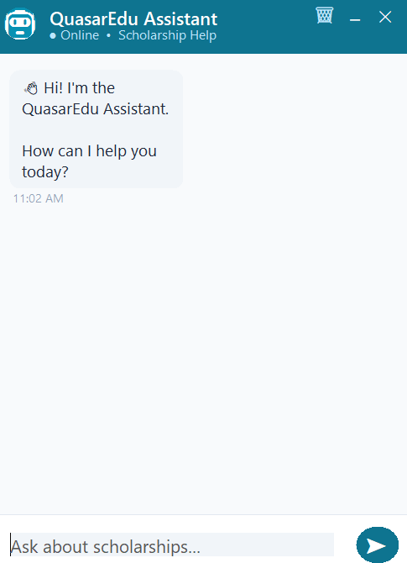

3.4 Reports & Report Layouts

Report 1 — Application Receipt
Generated by ApplicationReceiptService.cs. Produces a formatted printable receipt using the Windows Forms print subsystem.
Section | Content
Header | QuasarEdu logo text, 'Scholarship Application Receipt', generation date & time
Student Block | Full Name, CNIC, Email, Mobile, Department, Degree Program, CGPA
Scholarship Block | Title, Amount, Deadline, Need-Based flag
Application Block | Application ID, Applied Date, Status, Admin Comments, Fingerprint Verified flag
Footer | Disclaimer: 'This receipt is system-generated'; page number

Report 2 — Document Print Report
Generated by DocumentPrintService.cs. Produces a summary sheet listing all documents uploaded by the student.
Column | Description
# | Sequential row number
Document Type | E.g. CNIC Front, HSSC Certificate, Face Verification
File Name | Original file name stored on disk
Upload Date | DATETIME2 formatted as dd-MMM-yyyy HH:mm

Report 3 — Student Applications Report (Admin)
Accessed from Admin Dashboard > Applications tab. Displays all applications system-wide.
Column | Description
Application ID | Unique application identifier
Student Email | Applicant's email address
Scholarship Title | Linked scholarship name
Amount (PKR) | Scholarship value
Status | Colour-coded status pill
Applied Date | Date of submission
Review Date | Date admin last reviewed
Fingerprint Verified | Boolean — Yes / No

Report 4 — Eligible Scholarships Report (Student)
Shown on the student dashboard and Apply Form. Filters are applied server-side.
Column | Description
Title | Scholarship name
Amount (PKR) | Award amount
Deadline | Application deadline or 'Open'
Min. CGPA | Minimum CGPA required or 'None'
Max Income | Maximum family income or 'None'
Need-Based | Yes / No
Actions | Apply | Save buttons

Report 5 — Fingerprint Verification Status Report (Admin)
Based on the vw_FingerprintStatus view. Shows all approved applications with their verification link status.
Column | Source
Application ID | Applications.Id
Student Email | Applications.UserEmail
Scholarship Title | Scholarships.Title
Application Status | Applications.Status
Fingerprint Verified | Applications.FingerprintVerified
Verified At | Applications.FingerprintVerifiedAt
Token | FingerprintVerificationTokens.Token (truncated)
Token Expires At | FingerprintVerificationTokens.ExpiresAt
Token Used | FingerprintVerificationTokens.IsUsed

Report 6 — Identity Verification Status Report
Tracks which students have completed the initial face + biometric identity check required before applying.
Column | Description
Student Email | Primary identifier
Student Name | From Students table
Identity Verified | Derived from FingerprintTemplate IS NOT NULL AND starts with 'IDENTITY_VERIFIED:'
Verification Method | Extracted from the template marker (fingerprint_camera | biometric | pin_code)
Verified On | Timestamp embedded in the template marker
Token Used | IdentityVerificationTokens.IsUsed

Report 7 — Admin Stats Panel (live)
Rendered live on AdminDashboard via LoadStats(). Executes a single batched SQL query and populates four stat label controls in real time.
Stat Tile | Value / Source
Total Scholarships | COUNT(*) FROM Scholarships → lblStatValue1
Total Applications | COUNT(*) FROM Applications → lblStatValue2
Pending Reviews | COUNT(*) WHERE Status = ‘Pending’ → lblStatValue3
Approval Rate | ApprovedCount * 100 / ReviewedCount (0 % guard) → lblStatValue4

Report 8 — Application Status Pie Chart (live)
Rendered live on AdminDashboard via LoadChart(). Uses Guna.Charts.WinForms GunaPieDataset to display the distribution of application statuses. Toggled by the Chart button; refreshed on demand via BtnRefresh.
Property | Detail
Chart Control | GunaChart (chartStatus) using GunaPieDataset
Data Query | SELECT Status, COUNT(*) AS Count FROM Applications GROUP BY Status ORDER BY Status
Slice Labels | Approved, Pending, Rejected, Withdrawn (one slice per status returned)

Report 9 — Scholarship Eligibility Grid (live)
Rendered live on StudentDashboard and ApplyForm via LoadScholarships(). Filters scholarships server-side against the student’s CGPA, family income, degree program, and semester. Colour-coded eligibility rating guides the student toward the best matches.
Column | Description
Title | Scholarship name
Amount (PKR) | Award amount in PKR
Deadline | Application deadline or ‘Open’
Eligibility Rating | Colour-coded score derived from EvaluateScholarship() (green / amber / red)
Need-Based | ✔ / ✘ (NeedBasedDisplay column)
Actions | Apply │ Save buttons; Apply disabled if already applied or identity not verified

Report 10 — Student Application History Grid (live)
Rendered live in ApplicationsForm (opened from StudentDashboard). Shows the logged-in student’s full application history with real-time status, admin comments, and contextual action guidance.
Column | Description
Scholarship | ScholarshipTitle — linked scholarship name
Status | Pending / Approved / Rejected / Withdrawn
Date Applied | AppliedDate formatted as dd MMM yyyy
Admin Comments | AdminComments from the review; shown when Approved or Rejected
Action | Contextual guidance text (PrepareDataTable); highlighted red for ‘No Action Required’

CHAPTER THREE — Classes, Methods & Class Diagram

4.1 Final Classes of the Project
The Windows Forms application is structured using a layered architecture: Models → Repositories → Forms / Services. The web API (FingerprintVerificationApi) is a single-file Minimal API with inline record types.

4.2 Models

Entity (base class)
Member | Type | Description
Id | int { get; set; } | Auto-increment surrogate primary key shared by all entities

User : Entity
Property | Type | Description
Email | String | Unique email address; used as FK in child tables
Password | String | Credential (plain text in development)
Role | String | "Student" or "Admin"; defaults to "Student"
IsVerified | Bool | True after OTP confirmation
FullName | string? | Display name
Phone | string? | Contact number
Address | string? | Free-text address
DateOfBirth | DateTime?
CreatedAt | DateTime | Account creation timestamp

Student : User
Inherits all User properties and adds:
Property | Type | Description
UserEmail | string? | FK back-reference (mirrors Email in DB)
FatherName | string?
CNIC | string? | National identity number
MobileNumber | string?
Gender / Religion | string?
DateOfAdmission | DateTime?
DisabilityStatus / DisabilityDetail | string?
FamilyIncome | decimal? | Annual household income
SemesterYear | string? | e.g. "Fall 2024"
RollNumber / RegistrationNumber | string? | Institution-assigned IDs
Department / DegreeProgram | string?
UniversityName | string?
CGPA | decimal? | 0.00 – 4.00
DomicileDistrict / Province / District / TownVillage | string? | Address hierarchy
MailingAddress / PermanentAddress | string?
SSCBoard, SSCRollNo, SSCYear, SSCMarks, SSCPercentage, SSCInstitute | Mixed | Secondary school academic record
HSSCBoard, HSSCRollNo, HSSCYear, HSSCMarks, HSSCPercentage, HSSCInstitute | Mixed | Higher secondary academic record
FingerprintTemplate | byte[]? | Raw biometric template or identity-verification marker
UpdatedAt | DateTime?

Scholarship
Property | Type | Description
Id | int | PK
Title | string | Name of the scholarship
Description / Eligibility | string? | Freeform descriptive text
Amount | decimal | Award value in PKR
Deadline | DateTime? | Null = open-ended
IsActive | bool | Soft-delete flag
RequiredDocuments | string? | Comma-separated list
MinimumCGPA | decimal?
MaxFamilyIncome | decimal?
DegreeProgram | string?
SemesterYear | string?
NeedBased | bool
CreatedAt | DateTime

Application
Property | Type | Description
Id | int | PK
ScholarshipId | int | FK → Scholarships.Id
UserEmail | string | FK → Users.Email
Status | string | Pending | Under Review | Approved | Rejected
AppliedDate | DateTime
ReviewDate | DateTime?
Comments | string? | Admin notes
StudentComments | string? | Applicant personal statement
FingerprintVerified | bool
FingerprintVerifiedAt | DateTime?

Document
Property | Type | Description
Id | Int | PK
UserEmail | String | Owner
DocumentType | String | e.g. 'CNIC Front', 'Face Verification'
FileName | String | Stored file name
FilePath | String | Absolute path on server disk
UploadDate | DateTime

Notification
Property | Type | Description
Id | Int | PK
UserEmail | String | Recipient
Message | String | Notification body text
IsRead | Bool | Read/unread flag
CreatedDate | DateTime

SavedScholarship
Property | Type | Description
Id | Int | PK
UserEmail | String | Student who saved
ScholarshipId | Int | FK → Scholarships.Id
SavedDate | DateTime | Bookmark timestamp

4.3 Infrastructure Classes

Database (static class)
Member | Return Type | Description
ConnectionString | const string | Connection string targeting local SQL Server, database 'ft', integrated security
GetConnection() | SqlConnection | Opens and returns a new SqlConnection
Query(string sql, params SqlParameter[]) | DataTable | Executes a SELECT and fills a DataTable via SqlDataAdapter
Execute(string sql, params SqlParameter[]) | int | Executes INSERT/UPDATE/DELETE; returns rows affected
Scalar(string sql, params SqlParameter[]) | object? | Executes scalar (e.g. COUNT) and returns the first-column first-row value
ExecuteProcedure(string proc, params SqlParameter[]) | DataTable | Executes a named stored procedure

Session (static class)
Member | Type | Description
UserId | int? | Id of the currently logged-in user
UserEmail | string? | Email of the current user; used as FK in most queries
UserRole | string? | 'Student' or 'Admin'
FullName | string? | Display name shown in UI
Phone / Address / DateOfBirth | Mixed | Cached profile fields
Department / DegreeProgram / SemesterYear | string? | Cached academic fields for eligibility filtering
FamilyIncome / CGPA | decimal? | Cached financial/academic fields for eligibility filtering
Logout() | void | Clears all session properties to null

Utils (static class)
Method | Description
SendOTPEmail(string to, string otp) | Sends a 6-digit OTP via Gmail SMTP for account verification or password reset
SendVerificationLinkEmail(string to, string studentName, string scholarshipTitle, string token, string apiBase) | Emails a scholarship fingerprint-verification link (valid 48 h) to an approved applicant
SendIdentityVerificationLinkEmail(string to, string studentName, string token, string apiBase) | Emails an identity verification link for initial biometric registration

4.4 Repository Classes

UserRepository
Method | Return Type | Description
GetByEmail(string email) | User | Fetches a User record by email; returns null if not found
Register(string email, string password, string fullName) | int | Calls sp_RegisterUser; returns new user Id
VerifyOTP(string email, string otp) | bool | Validates OTP and sets IsVerified = 1
UpdatePassword(string email, string newPassword) | void | Resets password after OTP-confirmed forgot-password flow
UpdateProfile(User u) | void | Updates Phone, Address, DateOfBirth, FullName

StudentRepository
Method | Return Type | Description
GetByEmail(string email) | Student | Fetches the full Student profile joined with academic fields
Upsert(Student s) | void | Calls sp_UpsertStudentProfile — inserts or updates profile in one operation
GetAll() | DataTable | Returns all student records for the admin student list
SaveFingerprintTemplate(string email, byte[] template) | void | Stores raw biometric template bytes in FingerprintTemplate column

ScholarshipRepository
Method | Return Type | Description
GetAll(bool activeOnly) | DataTable | Returns all scholarships; optionally filters by IsActive
GetEligible(string email) | DataTable | Calls sp_GetEligibleScholarships — filters by CGPA, income, program
GetById(int id) | Scholarship | Fetches a single scholarship by Id
Create(Scholarship s) | int | Calls sp_CreateScholarship; returns new Id
Update(Scholarship s) | void | Updates all mutable scholarship fields
Deactivate(int id) | void | Sets IsActive = 0

ApplicationRepository
Method | Return Type | Description
HasApplied(int scholarshipId, string email) | bool | Returns true if a Pending or Approved application already exists
GetMyApplications(string email) | DataTable | Returns all applications for the student with scholarship details
GetAll() | DataTable | Admin — returns all applications system-wide
Submit(int scholarshipId, string email, string comments) | string | Calls sp_SubmitApplication; returns status message output parameter
UpdateStatus(int appId, string status, string comments) | void | Calls sp_UpdateApplicationStatus
SendFingerprintLink(int appId, string email) | void | Generates token, inserts into FingerprintVerificationTokens, calls Utils.SendVerificationLinkEmail

4.5 Service Classes

ApplicationReceiptService
Method | Description
Print(Application app, Student student, Scholarship scholarship) | Builds and sends a PrintDocument to the default printer with a multi-section application receipt layout
OnPrintPage(object sender, PrintPageEventArgs e) | Event handler that draws header, student block, scholarship block, application block, and footer using GDI+ Graphics calls

DocumentPrintService
Method | Description
Print(List<Document> documents, string studentName) | Renders a tabular document listing to the default printer

4.6 Web API Classes (FingerprintVerificationApi)
The API is implemented as a single-file ASP.NET Core Minimal API. All types are record declarations within Program.cs.
Record / Type | Members | Purpose
TokenInfo | ApplicationId, UserEmail, StudentName, ScholarshipTitle, ExpiresAt, IsUsed | DTO for a scholarship fingerprint verification token row
VerifyRequest | Token, Method | POST body for /api/verify-complete
IdentityTokenInfo | UserEmail, StudentName, ExpiresAt, IsUsed | DTO for an identity verification token row
IdentityVerifyRequest | Token, CaptureMethod, FaceImageBase64, ImageBase64, BiometricCredential, FingerCaptures | POST body for /api/identity-verify-complete
EmailUtils (static class) | SendIdentityVerificationConfirmationEmail(toEmail, studentName, method) | Sends HTML confirmation email after identity verification

4.7 API Endpoint Summary
Method | Route | Description
GET | /verify?token=… | Validates scholarship fingerprint token; redirects to verify.html or shows error page
GET | /api/token-info?token=… | Returns JSON with token validity, student name, scholarship title
POST | /api/verify-complete | Marks token as used; updates Application.FingerprintVerified; inserts notification
GET | /identity-verify?token=… | Validates identity token; redirects to identity-verify.html or shows error
GET | /api/identity-token-info?token=… | Returns JSON with token validity and student name
POST | /api/identity-verify-complete | Saves face selfie + biometric/fingerprint data; marks token used; updates FingerprintTemplate; sends confirmation email

4.8 Request Model — IdentityVerifyRequest
Field | Type | Description
Token | string? | One-time identity verification token
CaptureMethod | string? | One of: 'fingerprint_photo', 'biometric', 'pin_code'
FaceImageBase64 | string? | Base64 JPEG of face selfie (always present)
FingerCaptures | Dictionary<string,string>? | Keyed fingerprint images: right_thumb, right_4fingers, left_thumb, left_4fingers
BiometricCredential | string? | WebAuthn / Face ID / PIN credential string
ImageBase64 | string? | Fallback: single step-2 image

4.9 Verification Flow
- Student clicks 'Verify Identity' in ProfileForm.
- App creates an IdentityVerificationTokens row (expiry = now + 1 hour) and emails the link.
- Student opens the link on their smartphone; the API validates the token and serves the verification HTML page.
- Step 1: Student takes a face selfie (camera capture in browser) - Mandatory.
- Step 2: Student chooses Fingerprint Photo (camera), Biometric (Face ID / Touch ID via WebAuthn), or PIN/Password.
- Browser POSTs to /api/identity-verify-complete with the token and captured data.
- API atomically claims the token, deletes old identity documents, saves new files to C:\ScholarshipApp\Uploads, inserts Document rows, writes identity marker to Students.FingerprintTemplate, inserts Notification, sends confirmation email.
- WinForms application detects the verification on next profile load or when Apply is clicked.

4.10 Cloudflare Tunnel Setup
The Cloudflared binary creates an outbound-only tunnel from the local machine to a Cloudflare edge node, providing a public HTTPS URL without opening firewall ports or configuring a static IP. The tunnel URL is pasted into Utils.FingerprintServerBaseUrl before running the WinForms app.

4.11 Class Diagram (Summary)
The diagram below describes the inheritance and association relationships between all classes in the Windows Forms project:
Class | Inherits / Implements | Associates With
Entity | — | Base for User, Scholarship, Application, Document, Notification, SavedScholarship
User | Entity | Student (1:1), Session (runtime)
Student | User | ApplicationRepository (via email), StudentRepository
Scholarship | Entity | ScholarshipRepository, ApplicationRepository
Application | Entity | ApplicationRepository, ApplicationReceiptService
Document | Entity | DocumentPrintService
Notification | Entity | NotificationsForm
SavedScholarship | Entity | StudentDashboard, ApplyForm
Database | static | All Repository classes
Session | static | All Forms (reads current user)
Utils | static | Register, OTP, AdminDashboard, ApproveRejectForm
UserRepository | — | Database, User
StudentRepository | — | Database, Student
ScholarshipRepository | — | Database, Scholarship
ApplicationRepository | — | Database, Application, Utils
ApplicationReceiptService | — | Application, Student, Scholarship
DocumentPrintService | — | Document

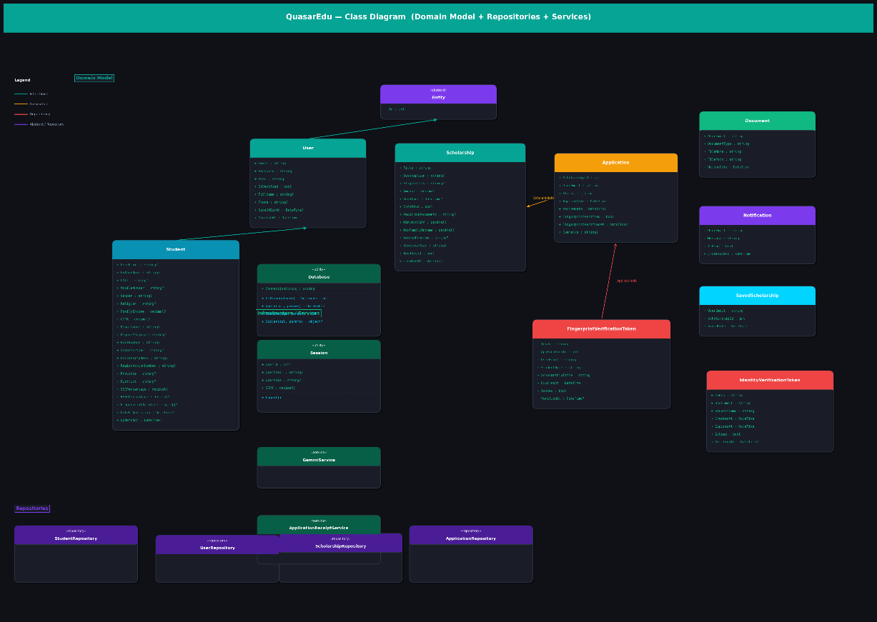

APPENDIX A — Stored Procedures & Views
Name | Type | Description
sp_RegisterUser | SP | Inserts a new User record; throws if email already exists
sp_UpsertStudentProfile | SP | INSERT or UPDATE student profile in a single call; preserves existing FingerprintTemplate if new value is NULL
sp_GetStudentProfile | SP | SELECT * FROM Students WHERE UserEmail = @email
sp_CreateScholarship | SP | Inserts a new Scholarship and returns its new Id
sp_GetEligibleScholarships | SP | Returns active, non-expired scholarships matching the student's CGPA, income, and degree program, excluding already-applied ones
sp_SubmitApplication | SP (OUTPUT) | Validates student eligibility; checks for duplicate active applications; inserts Application row; returns status message via OUTPUT parameter
sp_UpdateApplicationStatus | SP | Updates Status, Comments, and ReviewDate on an Application
sp_GetStudentApplications | SP | Returns applications with scholarship details, admin comments, and student comments for a given email
vw_FingerprintStatus | VIEW | Joins Applications, Scholarships, and FingerprintVerificationTokens to show verification status for all approved applications

Indexes
Index Name | Table | Columns | Type
IX_Students_UserEmail | Students | UserEmail | NONCLUSTERED
IX_Students_CNIC | Students | CNIC (WHERE NOT NULL) | NONCLUSTERED FILTERED
IX_Scholarships_Active_Deadline | Scholarships | IsActive, Deadline INCLUDE MinimumCGPA, MaxFamilyIncome, DegreeProgram | NONCLUSTERED
IX_Applications_Student_Scholarship | Applications | UserEmail, ScholarshipId | NONCLUSTERED (non-unique after replication fix)
IX_FingerprintTokens_Token | FingerprintVerificationTokens | Token | NONCLUSTERED
IX_FingerprintTokens_Email | FingerprintVerificationTokens | UserEmail | NONCLUSTERED
IX_IdentityTokens_Token | IdentityVerificationTokens | Token | NONCLUSTERED
IX_IdentityTokens_Email | IdentityVerificationTokens | UserEmail | NONCLUSTERED

Appendix B — Security Features
# | Feature | Implementation Detail
1 | Brute-Force Protection | 5 failed login attempts per email → 15-minute lockout stored in memory; admin accounts excluded
2 | OTP Expiry | 5-minute window; max 3 attempts before Login.cs force-closes the OTP form
3 | Caps Lock Warning | ToolTip appears on password TextBox when Caps Lock is active
4 | File Upload Whitelist | Only .pdf, .jpg, .jpeg, .png accepted in ProfileForm and ApplyForm
5 | File Open Security | Extension re-checked against whitelist before ProcessStart shell open
6 | Input Validation | CNIC 13 digits; mobile +923/03 format; CGPA 0.00–4.00; percentages 0–100; years 1950–current
7 | SQL Injection Prevention | All queries use SqlParameter throughout Database, Repository, and Form code
8 | Password Hashing | BCrypt.Net-Next v4.2.0 with plain-text fallback for legacy accounts (migration in progress)
9 | Concurrency Safety | Approve/reject SQL uses WHERE Status = 'Pending'; warns if already processed
10 | SQL Transactions | ApplyForm and ApproveRejectForm wrap INSERTs/UPDATEs in SqlTransaction with full Rollback on failure
11 | Session Validation | Each Dashboard.Load() checks Session.UserEmail; null → redirects to Login
12 | Token Security | Identity and fingerprint verification tokens: 64-char random hex, 1-hour expiry, single-use (atomic UPDATE IsUsed = 1 WHERE IsUsed = 0)
13 | CORS | Verification API uses AllowAnyOrigin/Method/Header — suitable for the controlled tunnel environment

Appendix C — Navigation Flow
Program.Main()
└─ Loading (progress bar splash)
└─ Login
├─ Register → OTP → StudentDashboard
├─ ForgotPasswordForm → (verify OTP → reset password) → Login
├─ StudentDashboard [role = Student]
│ ├─ ProfileForm (edit profile + documents + identity verification)
│ ├─ ApplyForm (upload docs + submit application)
│ ├─ ApplicationsForm (view / withdraw / reapply / download receipt)
│ ├─ NotificationsForm (read messages)
│ └─ Logout → Login
└─ AdminDashboard [role = Admin]
├─ AddEditScholarshipForm (create / edit scholarship)
├─ ApproveRejectForm
│ ├─ AllDocumentsForm (view student documents)
│ └─ StudentProfilePopupForm (read-only profile)
├─ StudentListForm
│ └─ StudentProfilePopupForm
├─ AllDocumentsForm
└─ Logout → Login

